CONTRACT AGREEMENT

by and between

THE CHICKASHA BOARD OF EDUCATION

And

THE CHICKASHA ASSOCIATION OF SUPPORT EMPLOYEES

SCHOOL YEAR 2024-2025

**Summer 2024 negotiations are highlighted.**

Table of Contents

ARTICLE I: NON-DISCRIMINATION CLAUSE 5

ARTICLE II: SAVINGS CLAUSE 5

ARTICLE III: PRINTING AND DISTRIBUTION OF THE CONTRACT 5

ARTICLE IV: ORGANIZATION RIGHTS AND PRIVILEGES 6

ARTICLE V: REPRESENTATION ON COMMITTEES 6

ARTICLE VI: PAYROLL DEDUCTIONS 7

ARTICLE VII: SAFETY AND HEALTH 7

ARTICLE VIII: POSTING OF VACANCIES 9

8.5 EMPLOYEE OF THE QUARTER 10

ARTICLE IX: INDIVIDUAL CONTRACT 11

9.3 Full Time and Part Time Personnel: 11

ARTICLE X: BREAK ROOM FACILITIES 13

ARTICLE XI: TELEPHONE FOR PRIVATE USE 13

ARTICLE XII: HEALTH EXAMINATION OF SCHOOL EMPLOYEES 13

ARTICLE XIII: ACTIVITY BUS DRIVING 13

ARTICLE XIV: PERSONNEL FILE 16

ARTICLE XV: TRANSFERS 16

ARTICLE XVI: INVOLUNTARY TRANSFER 17

ARTICLE XVII: DISMISSAL PROCEDURES 17

ARTICLE XVIII: REDUCTION SUPPORT PERSONNEL/ WORKFORCE 20

ARTICLE XIX: EVALUATION 21

ARTICLE XX: SICK LEAVE AND ACCUMULATION 22

ARTICLE XXI: EMERGENCY LEAVE 24

ARTICLE XXIII: LEAVES OF ABSENCE 25

ARTICLE XXIV: ASSOCIATION LEAVE 25

ARTICLE XXV: BEREAVEMENT LEAVE 26

ARTICLE XXVI: JURY DUTY LEAVE 26

ARTICLE XXVII: MATERNITY LEAVE 27

ARTICLE XXVIII: HOLIDAYS 27

ARTICLE XXIX: VACATIONS 27

ARTICLE XXX: PAY PERIODS 29

ARTICLE XXXI: PAY SCALES (MOVED TO THE BACK OF THE AGREEMENT) 30

ARTICLE XXXII: MEDICAL, DENTAL, VISION, AND LIFE INSURANCE 30

ARTICLE XXXIII: RETIREMENT 30

ARTICLE XXXIV: WORKERS COMPENSATION 31

ARTICLE XXXV: ACTIVITIES PASSES 32

ARTICLE XXXVI: MILEAGE 32

ARTICLE XXXVII: EXTENSION OF THE WORK YEAR 32

ARTICLE XXXVIII: GRIEVANCE PROCEDURE 33

37.1 Definitions: 33

37.2 Procedure for Filing a Grievance: 33

37.2.1 Informal Resolution: 33

37.2.2 Formal Resolution: 33

37.3 General Provisions: 35

ARTICLE XXXIX: ABSENCE NOT COVERED BY LEAVE 35

ARTICLE XL: OVERTIME 35

ARTICLE XLI: SECRETARIES WORKDAY 35

ARTICLE XLII: SITE-BASED DECISION MAKING 36

ARTICLE XLIII: TERMS OF AGREEMENT 37

ATTACHMENTS 38

SUPPORT EMPLOYEE JOB DESCRIPTION AND SALARY SCHEDULES 39

(SECTION XXX (30) OF THE MASTER CONTRACT BETWEEN CASE AND THE BOARD) 44

CASE PROCEDURAL AGREEMENT 46

PURPOSE 46

I RECOGNITION 46

II SCOPE OF BARGAINING 47

III NEGOTIATIONS PROCEDURES 47

IV IMPASSE 49

V. NO STRIKE CLAUSE 52

VI SAVINGS CLAUSE 52

VII DURATION OF AGREEMENT 52

PERFORMANCE APPRAISAL FOR SUPPORT PERSONNEL 54

EDUCATIONAL SUPPORT PROFESSIONAL OF THE QUARTER (NOMINATIONFORM) 56

SUPPORT PERSONNEL VOLUNTARY TRANSFER REQUEST FORM 57

CHICKASH PUBLIC SCHOOLS LEAVE REQUEST FORM 58

CHICKASHA PUBLIC SCHOOL EMPLOYEE CHANGE FORM 59

STATE INSURANCE CHANGE OF ADDRESS FORM 60

EMPLOYEE RESIGNATION FORM 61

EMPLOYEE EXIT INFORMATION FORM 62

EXTRA DUTY PAY TABLE 64

# ARTICLE I: NON-DISCRIMINATION CLAUSE

1.1 Non-Discrimination: The Board and CASE agree to abide by applicable state and federal laws and regulations pertaining to non-discriminatory practices.

# ARTICLE II: SAVINGS CLAUSE

2.1 In the event that any provisions of this agreement be declared invalid by statute or by a court of competent jurisdiction, now or hereinafter, then such provisions shall no longer be operative, but all other provisions of this agreement shall continue in effect. Upon request by the Board or CASE, the teams representing the Board and CASE shall within twenty (20) working days commence negotiations of a legally permissible replacement for the provisions affected.

2.2 If a change in statute or decision of a court of last resort results in a change in benefits to the employee, the change will be incorporated (*Revised 2019*).

# ARTICLE III: PRINTING AND DISTRIBUTION OF THE CONTRACT

3.1 For the parties to discuss responsibility for the master agreement and assuring, that within a reasonable time following approval of annual changes or additions to the master agreement, a final agreement is prepared, timely circulated, and available to the respective parties. The Superintendent will designate a primary contact for the Association Officers to communicate with to comply with this expectation of completion within a timely period.

3.2 The negotiating teams (The Association Team and the Board Team) will collaboratively proof a draft copy of the master contract prior to closing negotiations. Following ratification by both parties, the Superintendent (under the direction of the Board) will provide a proof perfect copy for posting. (*Revised 2020*)

3.3 The ratified CASE Master Contract/ Agreement will be posted to the Chickasha Public Schools website within ten (10) days following approval by the Board. (*Revised 2020*)

# ARTICLE IV: ORGANIZATION RIGHTS AND PRIVILEGES

4.1 Organization Meetings: Upon approval of the Superintendent or his/her designee, CASE may hold meetings in District-owned buildings.

4.2 Mail: Upon approval of the Superintendent or his/her designee, CASE may use the inter-school mail service to communicate with its members.

4.3 Printing and Email: Upon approval of the Superintendent or his/her designee, CASE shall be permitted to use (District) Email, District-owned printing and copying equipment. Supplies used for CASE publications shall be furnished or paid for by CASE. A usage charge may be mutually agreed upon by the Superintendent and CASE President.

4.4 Bulletin Board: CASE will be permitted to use bulletin board space in a designated area of each school site for posting of materials, provided such materials have been approved by the Superintendent or his/her designee prior to the posting.

4.5 Board Packet: The Board shall provide the CASE President a copy and/or email of the complete general public record information agenda packet of every Board meeting at the time the agenda packet is distributed to the School Board members. (*Revised 2020*)

4.6 Board Minutes: The Board shall provide the CASE President a copy and/or email of official minutes of each Board meeting at the time approved by the Board.

4.7 Board Policy Updates: Updates to the Board Policies will be maintained on the district website and will be available to CASE via District website. The Superintendent and his/her designees will make every effort to ensure that all updated District Policies and Procedures are posted on the district website as soon as possible after they are approved/ adopted by the Chickasha School Board of Education.

# ARTICLE V: REPRESENTATION ON COMMITTEES

5.1 Case shall have at least one representative of its choosing on all committees established by the Board, for the purpose of making recommendations which will affect change in compensation and/or working conditions of support employees.

# ARTICLE VI: PAYROLL DEDUCTIONS

6.1 In addition to those deductions required by state and federal law, each support employee may, upon written authorization, initiate the following payroll deductions:

1. Oklahoma Educators Credit Union/ Focus Credit Union
2. District approved insurance programs
3. OEA/NEA/CASE Dues
4. U.S. Savings Bonds
5. Tax-Sheltered Annuities

Political Action Committee Contributions

6.2 Additional payroll deduction programs may be added based on approval of the Board and availability of computer slots.

# ARTICLE VII: SAFETY AND HEALTH

7.1 Working Conditions: Chickasha School Support Employees are protected in regard to working conditions and safety, according to state and federal statutes and regulations, and by Chickasha District Policies. (These include and not limited to the following regulatory agencies: OSHA, FLSA, State Workers Compensation Regulations, and State and Federal Homeland Security Regulations).

1. Staff members shall not be required to work under unsafe or hazardous conditions as determined by proper regulatory authorities. Staff members’ concerns shall be reported to a building administrator who shall then take appropriate action.
2. The procedure for handling complaints by a staff member regarding threats of harm by a student, parent or guardian, or other forms of harassment by a parent or guardian shall be developed by the District and included in the Administration Handbook at each site.
3. Any staff member upon whom an assault, battery, or aggravated battery or aggravated assault and battery is committed while in the performance of any duties as a school employee shall notify the principal in writing. The principal shall notify the superintendent or designee of the assault, battery, assault and battery, aggravated battery, or aggravated assault and battery. (This provision is consistent with 70 O.S. 5-146.)
4. Any student who threatens harm or assaults a staff member, as defined by this Negotiated Contract, and is removed from class, shall not be readmitted to the teacher’s class or extracurricular activity without communication between the teacher and the immediate supervisor or appropriate administrator.
5. Any student who has been suspended for a violent offense which is directed towards a employee shall not be allowed to return to that teacher’s classroom without approval of the designated committee.
6. ~~teacher who is unable to continue his/her contract of employment as a result of injury sustained in the reasonable performance of his/her duties from: assault by a pupil, relative of a pupil or person of the pupil’s household, or injury sustained as a result of the quelling or attempting to quell or stop a fight, disorder and/or disturbance related to school function or activity, shall be paid his/her full contract salary for the period of time as he/she is prevented from working as a result of injuries sustained during the performance of his/her duties up to the remainder of the contract year in which he/she was injured. No more than 3 sick leave days shall be charged against the teacher. The implementation of this paragraph is subject to State Workers Compensation rules and regulations.~~
   1. Any student in grades six through twelve who assaults, attempts to cause physical bodily injury, or acts in a manner that could reasonably cause bodily injury to a school employee or a person who is volunteering for the school shall be subject to out-of-school suspension as provided in 70 O.S. §24-101.3
   2. No school employee or person volunteering for the school shall be liable for the use of necessary and reasonable force to control and discipline a student during the time the student is in attendance at the school or in transit to or from the school, or any other function authorized by the school district.
7. The purpose of this section (*Protection of Teachers)* is to inform employees of the law and is not intended to provide greater or lesser benefits than included in Okla. Stat. tit. 70 35F. Revised 2025

7.2 Uniforms and Clothing Allowances:

1. The District shall provide a $200.00 (two hundred dollars) stipend per year uniform allowance for all food service personnel. The stipend will be provided in the October pay check. All cook/ servers MUST ~~wear uniforms, including non-skid leather shoes. NO SHORTS ALLOWED. (~~*~~Revised 2020~~*~~)~~ WEAR DISTRICT MANDATED APPROPRIATE ATTIRE, as well as non-skid leather shoes. NO SHORTS ALLOWED. (Revised 2024)
2. The District shall provide $150.00 (one hundred fifty dollars) per year uniform allowance for security guard personnel required to wear uniforms. This includes appropriate shoe wear. Reimbursement will not be made unless the person applying has a signed itemized receipt showing what was purchased. Also, reimbursement can only be made one time per year, per employee.
3. The District will provide district-designated shirts for maintenance, grounds, and custodial staff. The shirts will be directly purchased through the District at a rate of $65.00 (sixty-five dollars) per relevant employee.
4. The District will provide appropriate outerwear for employees assigned outdoor work tasks in inclement weather and in extreme conditions such as sewer cleaning, Mail Person, etc.
5. Bus Monitors Rain Gear: The District will provide rain gear for bus monitors to be used while on duty getting on and off the buses during inclement weather. Each bus monitor will be responsible for maintaining the rain gear in useable condition for a minimum of one school year.
6. As per standards of the Internal Revenue Service, uniform reimbursements of uniform costs will be calculated as additional compensation with appropriate withholdings.

7.3 Site Level Professional Development for Custodial Procedures and Processes: Each building site will schedule a meeting prior to the opening of the school, to include certified and support employees, to discuss the cleaning procedures and processes for the facilities. The meeting date, time and place will be determined by each site’s Building Principal. Suggested items to discuss (but not limited to) will include: procedures for cleaning; materials to be used and not to be used for cleaning; whom to contact when there are needs, safety and health issues, and classroom procedures for collaborating and communicating between the building site employees and the building site custodians.

# ARTICLE VIII: POSTING OF VACANCIES

8.1 The administration shall cause notices of vacancies for any support positions to be posted on the vacancy list on the Chickasha Public Schools Website and designated bulletin boards at each work site. Any new positions will be posted in the same manner. These notices shall be posted at least five (5) working days, ten (10) days if the vacancy occurs during the time when school is not in session, prior to the application deadline. In case of internal bus route opening created by a driver taking a different route, this route opening shall be posted for no less than twenty-four (24) hours if school is in session and not less than five (5) days if school is not in session.

8.2 These notices shall contain job title and date. Interested parties or applicants may contact the Superintendent’s office for more information.

8.3 Any employee who is on leave or for some reason away from his/her job may submit a letter of interest or transfer request form for any vacancy which may occur during his/her leave.

8.4 SUPPORT PERSONNEL POSIITON TITLES:

See attachment SUPPORT EMPLOYEE JOB DESCRIPTION AND SALARY SCHEDULES for up-to-date Position Titles.

* Child Nutrition Personnel: Assistant Leader, Department Head, Cook/ Server
* Secretaries: Building Secretary
* Deputy Treasurer, Board Clerk, Director’s Assistant and Activity Lunch Fund: Deputy Treasurer, Board Clerk, Director’s Assistant, Activity/ Lunch Fund Custodian
* Custodians: Head Custodians, Regular Custodians, Security Guards, Child Nutrition Delivery
* Grounds Maintenance:
* Maintenance Personnel: Unlicensed, Licensed I, Licensed II, Licensed III, and Maintenance Supervisor
* Bus Mechanic and Mechanics’ Helper: Mechanic’s Helper, Mechanic I, Mechanic II, and Mechanic III
* Skilled Labor: Helper, Level I, Level II and Level III
* Building Assistant, Library Assistant, Teacher Assistant Mail Delivery Person, In-School Suspension (ISS), Bus Monitor, Nurse Assistant, Paraprofessional I, Teacher Assistant, Bus Drivers and Interpreters:

## 8.5 EMPLOYEE OF THE QUARTER

(8.5.1) The Employee of the Quarter selection process:

1. the selection will be decided by the District’s team and CASE.
2. the recipient will receive a $300 stipend to be included in the following month’s pay period and will be recognized at the next regular board meeting.

(8.5.2) Employee of the Quarter Form Rules:

1. one submission per person per quarter.
2. submissions deadline is the end of each quarter.
3. all nominations must be in sealed envelopes.
4. all sealed envelopes will be opened only at the selection meetings.
5. no anonymous entries; all anonymous entries will be discarded.
6. any Chickasha Public School Employee may make a nomination.
7. nominations may be delivered or sent to the Superintendent’s office.
8. reminders, promotion and scheduling committee meetings of the Employee of the Quarter shall be initiated by CASE.
9. if no Employee of the Quarter is nominated for a specific quarter, none will be recognized in the future for that quarter. (Note: Possibly set committee meeting dates on Google Calendar for all quarters)

# ARTICLE IX: INDIVIDUAL CONTRACT

9.1 Contracts: Each support employee shall enter into an individual contract with the Board. This contract shall give details as to salary, hours and contract days. Such contract will be consistent with the terms of this agreement. In addition:

* ~~All Support Staff will have his/her employment contract ready to sign not later than November 15~~~~th~~ ~~of the current school year.~~
* Support staff hired prior to September 1st will have his/her employment contract and salary information sheet no later than October 15th, to be signed and returned no later than October 31st. (Revised 2024)
* Extra-Duty employment contracts will be signed at the time the extra-duty assignment is confirmed, or not later than ten (10) days following approval by the Chickasha Board of Education.
* If Collective bargaining/ negotiations are pending, the employment contracts will be signed within thirty (30) days following ratifications and approval of the Board, of the Master Contract/ Agreement. (*Revised 2020*)
* New yearly work calendars for all support positions should be sent out to all employees with re-hire letters by May 31st or 14 days following their being rehired by the board, unless there is a change in the calendar that would affect the work calendar. (Revised 2025)

9.2 All terms of this agreement shall be considered as terms of the individual contract between the Board and the support employee.

## 9.3 Full Time and Part Time Personnel:

1. Definition of Support Personnel: Full-time employees of the school district as determined by the standard period of labor which is customarily understood to constitute full-time employment for the type of services performed by the employees who are employed a minimum of six (6) hours per day for a minimum of one hundred seventy-two (172) days or a minimum of six (6) hours per day for one thousand thirty-two (1,032) hours per year and provide services not performed by certified personnel, which is necessary for the efficient and satisfactory functioning of the school district, and shall include but not limited to: cooks, custodians, maintenance personnel, bus drivers, non-certified or non-registered nurses, non-certified librarians, and clerical employees of the school district {70 O.S. §26-103(4)}.
2. Definition of Part-Time Support Personnel: Any individual who does not meet the definition of a full-time support employee, as defined in the above paragraph, and who meets all definitions on the basis of less than a minimum of six (6) hours per day, and/or less than one hundred seventy-two (172) days, and less than one thousand thirty-two (1,032) hours per year will be considered as “Part-time Support Personnel.”

9.4 Employee’s who work part time should be compensated for all approved hours worked. (i.e., if a monitor is hired on a 4 hour contract, and is assigned to a route that is 4.5-5 hours, that monitor should be compensated for the entire time they are on the bus for the route not just the contracted hours.) (Revised 2025)

9.5 On the day each contract is signed, a detailed job description will be attached.

9.6 On November 2001 support employees hired in the district for the first time begin on “Step 0” of the appropriate salary schedule with the following exception provision:

The employee may on the recommendation of the site leader where the vacancy exists, be advanced one (1) additional step for every two years of verified non-school experience from the most immediate employer ~~to a maximum placement of “Step 5.”~~ A letter on company letterhead from the previous immediate employer must be provided with the following information: the classification of employment, a brief description of duties, a general comment on quality of service, beginning date and ending date. (Revised 2025)

9.7 Right to Representation: Support staff members are entitled to have a representative of their choice present during a scheduled conference with an administrator. The nature of the meeting shall be disclosed in writing at the time the meeting is scheduled if it is a meeting for disciplinary action of any kind. If during a conference between a support employee and an administrator either the administrator or the employee feels that it would be in his/her best interest to have another person present, he/she may adjourn the conference and it shall be rescheduled on a mutually agreeable date/ time, and when a representative may be present and within two (2) business days. The nature of the meeting shall be disclosed in writing at the time the meeting is rescheduled. The Right to Representation will not supersede or override any part of the Grievance Articles and Processes (*Revised 2020*).

9.8 Dignity: While individual behavior cannot be negotiated or set into policy, it is nevertheless the desire of both the administration and support employees to state herein that they intend to treat each other with civility, dignity and respect. Administrators and support employees agree to make every effort to ensure that this message is conveyed not only to each other, but to the students and parents within the district, so that civility, dignity and respect will be reciprocated as it is given. By doing so the district is working toward its goals of strengthening community relations and improving the quality of education in Chickasha.

# ARTICLE X: BREAK ROOM FACILITIES

10.1 Break and Lunch Periods: All support employees shall have break and lunch periods as defined by Board Policy.

# ARTICLE XI: TELEPHONE FOR PRIVATE USE

11.1 Telephone Access:

1. All support employees shall have access to a telephone for use during breaks and lunch periods.
2. Personal cell phone use during contract hours for school business should be limited.
3. Cell phone use while driving school transportation vehicles is prohibited while the vehicle is in motion. (Revised 2024)

# ARTICLE XII: HEALTH EXAMINATION OF SCHOOL EMPLOYEES

12.1 Health Examinations: All support employees who are required by the school to have a physical examination after being offered employment by the district will do so at the school district’s expense.

# ARTICLE XIII: ACTIVITY BUS DRIVING

13.1 OPPORTUNITY TO DRIVE: The opportunity to drive activity buses will be given to both full time drivers and substitute drivers who are employed within the district for less than forty hours per week as long as driving does not interfere with any other duties in the District. In scheduling activity trips every effort shall be made to schedule trips in such a manner that a driver’s total hours will be under forty (40) hours per week. Within the first year of a new driver’s employment, the opportunity to drive activity routes is at the discretion of the route coordinator and transportation director. This is dependent on the type of trip, destination and driving performance.

13.2 TRIP ROSTER: Upon the first day of each school year a sign-up roster will be posted for all full-time drivers and substitutes to indicate if they are interested in driving activity trips. This roster will remain posted for the school year allowing any driver to add or remove his/her name from the roster at any time. Once a driver has removed his/her name from the roster, it must be entered at the bottom upon the driver’s decision to be placed on the trip roster list again.

13.3 TRIP ROTATIONS & TRIP POSTING: When an approved activity trip is received by the Director of Transportation it shall be posted for forty-eight (48) hours (if time allows) in the bus barn office. Any driver wishing to take this trip should sign the trip posting. The trip will be assigned to the person who has indicated that he/she wishes to take the trip who is closest to the top of the trip roster. Upon assignment of an activity trip the driver’s name will be moved to the bottom of the activity trip roster for future rotation. If a bus driver has indicated he/she wishes to take more than one trip that has been posted simultaneous, the assignment will be made on the basis of the trip that is to be taken first with the driver (who has indicated a desire to take the trip) closest to the top of the list receiving the first trip.

13.4 OVERNIGHT ACTIVITY TRIPS: The Board shall be responsible for providing lodging and meal(s) when drivers are assigned to overnight trips. On the first day of an overnight trip, time starts when the driver picks up the bus and ends when the bus is parked for the night. On the second and all subsequent days of overnight trips, driver time starts at the time the bus leaves the parking lot in the morning. Drivers are guaranteed eight (8) hours of time on these days. Time ends when the bus is parked for the night. Since meals are reimbursed, time is to be deducted for meals. The maximum time allowed per day is to be sixteen (16) hours.

13.5 ACTIVITY DRIVER PAY: Activity drivers will be paid their hourly rate. Hours worked over 40 hours per week will be paid at time and a half (Revised 2022). The hourly rate for activity drivers applies to total time spent on the activity trip in which the driver is on duty (i.e. from the time of pick up at the school, through the arrival at destination and any wait time, to the time of drop-off at the school). For trips that encompass six or more hours, the sponsoring organization will provide a meal.

13.6 ACTIVITY ROUTES: Activity routes would include a field trip of students or staff members during the fiscal year. It could also include any extracurricular activity that could include athletics, vocal and instrumental music, drama, academic teams, robotics, FFA and other career tech classes. These routes will be paid according to the negotiated contract. The school district will calculate overtime by utilizing the blended rate if a support employee has received time in two pay scales during the week and went over forty (40) hours.

13.7 SHUTTLE ROUTES: Shuttle routes include transporting students during the school day from one site to another. Examples of shuttle routes would include delivering and picking up students at Canadian Valley Technology Center, delivering students to the Middle School from the High School including athletes and FFA members, transporting Lincoln students to the Middle School for Band, transporting Middle School athletes to the High School after school, transporting special needs students to and from school during the school day if their class schedule has been reduced to a partial day. (The driver will receive regular bus driver wages for driving shuttle routes).

13.8 CONFLICT OF INTERPRETATION OF TRIPS: Should a driver have a conflict with the interpretation of activity or shuttle routes (13.6 or 13.7), they must submit a written request explaining their conflict to their immediate supervisor for clarification. The supervisor will give a written explanation of how the trip is classified within two (2) working days.

13.9 WORKING EXTRA-CURRICULAR EVENTS OUTSIDE THE REGULAR CONTRACTED DUTIES: Non-certified support staff members working at extra-curricular events outside their regular contract duties shall be paid Twelve Dollars ($12.00) per hour for specific assignments as authorized by the Superintendent and/or his/her designee(s). These positions include gatekeeper, concession workers, scorer, and clock-keepers. (Revised 2025)

# ARTICLE XIV: PERSONNEL FILE

14.1 The Board shall maintain an official personnel file at the Board office for each support employee.

14.2 Upon request, an employee may inspect his/her personnel file subject to the following:

1. Inspection shall be conducted at a time mutually agreed upon by the employee and the Superintendent or his/her designee.
2. Upon request, an employee may have his/her representative present during inspection.
3. Copies of material in an employee’s personnel file shall be provided upon request.

14.3 The employee will be given a copy of any material placed in his/her personnel file when the employee requests a copy.

14.4 The employee shall have the right to submit a written response to such material and have said response attached to the material to which it responds.

14.5 Reprimands and/or admonishments may be removed from the employee personnel file at any time by mutual agreement between employee and the Superintendent.

14.6 Contents of the personnel file shall be kept confidential, to the extent provided by law.

# ARTICLE XV: TRANSFERS

15.1 A request for a transfer shall be made in writing to the person(s) listed on the posted vacancy as the person to whom application is to be made. The request shall include the job title to which the support employee desires to be transferred.

15.2 Should a vacancy occur during the school year, requested transfers to this position will be considered at the time of the vacancy.

15.3 In filling vacancies, the administration will give first consideration to requested transfers prior to employing any new applicant. In considering the request for a support employee’s transfer, the receiving supervisor must be apprised of the transfer request.

15.4 If a transfer is denied, a written explanation of the denial will be forwarded to the support employee.

15.5 When an employee has been transferred and it has been determined by the administration that the position vacated is to be retained, the vacancy shall, when feasible, be filled by a substitute until a permanent employee is hired for that position.

# ARTICLE XVI: INVOLUNTARY TRANSFER

16.1 The district will solicit volunteers before starting the process of filling a vacancy with an involuntary transfer. Seniority will be considered, but not the final determining factor in selecting the employee to fill the open position. If it becomes necessary to fill a vacancy by an involuntary transfer or reassignment, a letter of notification of initial in keeping with the right to representation time frame will be sent to the employee (Revised 2022). The meeting will be held between the support employee and the supervisor. If the employee objects to the transfer, reasons for the objection will be written to the supervisor. A copy of administrative remarks will be given to the support employee. A written letter stating the results of the meeting should be given to the employee, with a copy placed in the employee file at administration. These letters should come from the Superintendent's/Personnel Office. (*Revised 2021*)

# ARTICLE XVII: DISMISSAL PROCEDURES

17.1 In order to comply with Title 70 of the Oklahoma Statutes, sections 24-132 through 24-136, the Board hereby adopts the following procedure for the suspension, demotion or termination of support employees.

17.2 For the purpose of this policy a “support employee” is defined as an employee of a school District who provides those services, not performed by professional educators or licensed teachers that are necessary for the efficient and satisfactory functioning of a school district.

17.3 A support employee who has been employed by the Chickasha School District for more than one (1) year shall be subject to suspension, demotion or termination only for cause, as designated by this policy. A support employee who has been employed by Chickasha School District for less than one (1) calendar year shall be an at-will employee.

17.4 Nothing contained in this agreement shall prevent the Board of Education from acting on its own volition in matters pertaining to suspension, demotion or termination of support employees.

17.5 Whenever the Superintendent of Schools is of the opinion that the immediate suspension of a support employee is necessary and in the best interest of the school district, the Superintendent may suspend the employee without notice or hearing. If an employee is suspended for a period exceeding ten (10) days, the Superintendent of the District shall initiate proceedings for termination and shall follow procedures set forth in this policy. However, in a case involving a criminal charge, the suspension may be delayed until the case is adjudicated at trial. Noting herein shall prevent proceedings against the employee during or after the suspension or termination as provided in this policy.

17.6 Prior to any demotion or termination the support employee shall receive notice of his or her right to a hearing, which if requested will be conducted by the Board. All notices shall be by certified mail, with the postmark used to determine the timeliness of such notice. The support employee must request a hearing within ten (10) working days of said notice or be deemed to have waived his or her right to a hearing.

17.7 If a support employee requests a hearing, the hearing will be conducted (at the next or next succeeding, regularly scheduled meeting) of the Board if the request is received by the clerk of the Board at least ten (10) working days prior to the aforesaid meeting. A special meeting may be conducted if requested by the employee or at the discretion of the Board. The special meeting shall be conducted no sooner than ten (10) working days nor later than thirty (30) calendar days after receipt of employee’s request. The decision of the Board shall be final. Nothing in the above stated policy shall be construed to prevent layoffs for lack of funds or lack of work.

17.8 In order to comply with Title 70 of the Oklahoma Statutes Sections 24-132 and 24-136, The Board hereby adopts the following causes for suspension, demotion or termination.

1. Excessive failure to be at work site at starting time.
2. Leaving work site during working hours without permission.
3. Walking off the job.
4. Unexcused absenteeism.
5. Excessive wasting time or loitering during working hours.
6. Falsification of personnel or other records, (such as time sheets).
7. Possession of weapons on the premises at any time.
8. Removing District property, records or confidential information from premises without proper authority.
9. Willful abuse, misuse, defacing, sabotage or destruction of District property, including tools, equipment or the property of other employees.
10. Theft or misappropriation of property of employees, students, or of the District.
11. Insubordination of any kind.
12. Unauthorized operation of machines, tools or equipment.
13. Operating machines or equipment without safety devices provided.
14. Threatening, intimidation, coercing or interfering with employees or supervisor at any time.
15. The making or publishing of false statements concerning any employee, supervisor, or the District.
16. Creating disturbances on the premises at any time.
17. Creating or contributing to unsanitary conditions.
18. Possession, consumption or reporting to work under the influence of alcohol, non-prescribed drugs or controlled substances.
19. Disregard of known safety rules or common safety practices.
20. Unsafe operation of district owned motor vehicles.
21. Unauthorized distribution of literature, written or printed
22. matter of any description on district property.
23. Posting or removing notices or writing in any form on bulletin boards of district property at any time without specific authority of the administration.
24. Immoral conduct or indecency including abusive and/or foul language.
25. Smoking in an unauthorized area.
26. Failure to follow district dress code.
27. Abuse of “breaks” (rest periods) or meal period policies.
28. Poor workmanship.

17.9 Job Abandonment: An employee shall have abandoned his/her job when the employee has failed to call in and directly notify the supervisor of the reason for absence from work for three (3) consecutive workdays. Job abandonment will also occur when an employee fails to return to work or directly notify the supervisor of the reason for absence within three (3) consecutive working days after any approved leave of absence, disciplinary suspension or extended medical leave. When an employee has abandoned his/her job, that employee shall be immediately terminated from Chickasha Public Schools employment. Such termination shall be a voluntary resignation and shall not be subject to the grievance procedure.

# ARTICLE XVIII: REDUCTION SUPPORT PERSONNEL/ WORKFORCE

18.1 It is the policy of the Board that every reasonable effort shall be made to avoid a reduction in force at any level. However, when it becomes necessary to reduce the number of full-time or part-time support personnel employees due to lack of work or lack of funds in a particular area, the following criteria will govern their release. An employee is considered to be a full-time employee if the number of hours worked is the maximum number of hours customarily worked in that position if that position is designated as a full-time position by the Board. A reduction in force may occur for lack of work or lack of funds.

18.2 Whenever a reduction in force becomes necessary, all notices of layoffs shall be provided in the policy covering suspension, demotion or termination of support personnel. All notices shall be by written communication from the Board of Education or the designated representative of the Board to the concerned support personnel.

18.3 The number of people affected by a reduction in force will be kept to a minimum by not employing replacements for those who resign, retire, or otherwise vacate a position in so far as is practical.

18.4 Any layoff shall begin by first dismissing any temporary or part-time employees, in that order, within the job categories affected. These employees shall be laid off at the discretion of the Board or the Board’s designee. Job categories shall be the following; this is not to be considered the order for layoffs.

See attachment SUPPORT EMPLOYEE JOB DESCRIPTION AND SALARY SCHEDULES for job descriptions. (Revised 2025)

~~a. Building Assistants g. Secretaries~~

~~b. Bus Drivers h. Custodial~~

~~c. Maintenance i. Teacher Assistants~~

~~d. Child Nutrition Personnel j. Deputy Treasurer~~

~~e. Board Treasurer k. Activity Custodian~~

~~f. Board Clerk L. Lunch Custodian~~

18.5 If the normal attrition and the release of temporary or part-time employees does not sufficiently reduce the support staff, the following items will be considered in the reduction process in the order they are listed.

1. History of good performance, with few or no reprimands.
2. Qualified for job training and experience.
3. History of good attendance and punctuality.
4. When all employees within a category meet the above qualifications, layoffs shall be on the basis of seniority within each general job category. Supervisors and directors shall serve at the pleasure of the Board and will not be subjected to the prescribed seniority order for reduction in force. Seniority shall be defined as continuous length of service as a support employee within the district. Employees who are laid off as a result of reduction in force and subsequently reinstated shall retain cumulative seniority for all periods worked since the last hire except for the period of layoff.

18.6 An employee who takes voluntary demotions or voluntary reduction in assigned time in lieu of layoff shall be returned to the original position, if a vacancy for which the employee is qualified occurs. The Employee, if returned to the former position, will receive a step-raise, if a step-raise has occurred since the employee’s acceptance of a demotion. If an employee’s hours are increased due to a change in conditions resulting in a voluntary reduction in work hours – the employee shall receive the assigned pay rate for the position.

18.7 Support employees who have been dismissed as a result of reduction in force shall be recalled in reverse order of reduction (last to leave, first to be recalled) to fill any vacancy that occurs within their job category within the succeeding school year. (*Revised 2019*)

# ARTICLE XIX: EVALUATION

19.1 At the time of employment all new employees will be advised as to evaluation procedure and instruments.

19.2 Evaluations shall be conducted by supervisory personnel who have the responsibility to make recommendations for renewal or non-renewal of the employee contract and shall be conducted openly.

19.3 Each employee shall be evaluated at least once each year after he/she has completed his/her probation period. Evaluations are to be completed by May 1st~~15~~~~th~~. Meetings with Employees concerning employment, disciplinary action, and evaluations will be confidential. The employee should be given time to review all documentation and paperwork before signing. (Revised 2022) (Revised 2025)

19.4 The support employee will be given a copy of the evaluation report during a conference with the evaluating supervisor.

19.5 The support employee may respond to an evaluation within ten (10) working days and such response will be attached to the evaluation report and made a part of the record. Evaluations shall be maintained in the support employee’s personnel file. After one year the evaluation report may be removed from the file by mutual agreement between the support employee and the Superintendent or his/her designee.

19.6 Any complaint regarding an employee that may affect the support employee’s continued employment shall be made in writing and shall be called to the attention of the employee. Said employee shall have the right to respond to the complaint if it is to be placed in the employee’s personnel file.

19.7 If the supervisor considers the employee’s work to be unsatisfactory in some area(s), a written statement detailing the problem(s) will be issued to the employee. The supervisor will discuss the problems(s) with the employee and offer written suggestions for improvement. Failure to make the desired improvement within a reasonable amount of time that has been specified by the supervisor may result in dismissal.

19.8 The support personnel appraisal form is attached as an Appendix/ Attachment (to this Master Contract).

# ARTICLE XX: SICK LEAVE AND ACCUMULATION

20.1 Full-time support personnel shall receive one (1) day sick leave for each month of service. Part-time support personnel shall receive an equal number of hours for sick leave per month as they work per day. Example; a person working four (4) hours per day will get four (4) hours of sick leave per month. Sick leave shall be cumulative to one hundred and twenty (120) days for purposes of the state’s retirement system and for District severance pay. For personal need, sick leave is accumulative without limit.

20.2 New employees beginning employment prior to September of a school year may use one day of sick leave per month through December. Beginning in January new employees may use any leave accumulated plus the 5 days to be earned by the completion of the school year. Employees who leave employment and have taken unearned sick leave will be required to reimburse the district for their unearned sick leave. Reimbursement of unearned sick leave will be deducted from the final paycheck. Employees beginning employment after August of a school year may use leave as earned. (Revised 2022)

20.3 Sick leave may be used for personal accidental injury, illness or pregnancy or accidental injury or illness of the support employee’s immediate family. “Immediate family” shall include spouse, mother, father, children, brother, sister, mother-in-law, father-in-law, daughter-in-law, son-in-law, grandchildren and grandparents of employee or employee’s spouse or a person living in the support employee’s home who is part of the family.

20.4 The number of days of accumulated sick leave, if possible, shall be shown on the Support Personnel’s individual contract each year.

20.5 Upon retirement or leaving the District, each employee will be paid twenty (20) dollars per day for unused sick leave day accumulated within the District. This applies when the employee has given twenty (20) or more working days’ notice. If the employee has given less than twenty (20) working days’ notice, ten (10) dollars per day for each unused sick leave day will be awarded. If the employee is contracted for less than seven ~~and a half~~ (7~~.5~~) hours per day, the sick leave rate will be prorated according to the number of daily contracted hours. (Revised 2025)

20.6 For accumulation and buy-back purposes the amount of sick leave to be allowed in accumulation and subsequently in buy-back provisions of this contract, prior to July 1, 1987, shall not exceed the maximum accumulation allowed by board policy in effect at that time. Example; an employee employed by the Chickasha Public Schools before the first contract was negotiated by CASE, was allowed to accumulate sick leave days only in the amount provided for in Board policy. If the Board allowed sixty (60) days accumulation, then the employee could accumulate sixty (60) days. Any days beyond the sixty (60) accumulated are lost at that time and cannot be recalled counting toward a higher accumulation amount that was negotiated later.

20.7 Sick leave summaries will be provided to employees each month on the internet-based employee portal.

20.8 All employees (full-time or part-time) will be eligible to participate in sick leave sharing based on their hours worked. (Revised 2022)

# ARTICLE XXI: EMERGENCY LEAVE

21.1 Each support employee will be granted five (5)days paid emergency leave each school year. Emergency leave may be taken upon the approval of the Superintendent or his/her designee for emergency situations such as, but not limited to:

1. Incidents or circumstances which result in significant damage by unexpected acts or forces;
2. Illness or injury presenting a substantial likelihood of loss of life, limb or significant bodily function to members of the employee's immediate family as defined in “Sick Leave.”
3. Inclement weather: When weather is too dangerous for buses to roll out and or too dangerous for personnel to be on the roads. (Revised 2023)
4. ARTICLE XXII: PERSONAL BUSINESS LEAVE

22.1 The Board shall provide three (3) days personal business leave to each support employee each year. Support Employees with five (5) or more consecutive years of employment with the district shall have a total of four (4) days personal leave each year; and support employees with ten (10) or more consecutive years of employment with the district shall have a total of five (5) days personal leave year. Personal leave will be paid by the district.

22.2 Personal business leave may be used for personal business matters, such as: personal legal, household and/or business that must be conducted during normal working hours of the employee requesting the leave.

22.3 Personal business leave shall not be taken for pleasure trips, recreation or vacation, seeking or interviewing for other employment, performing a service for compensation, participation in professional activities, or participating in political activities. Except in cases of emergency, personal business leave shall not be used during the first two days of school for students; likewise, personal business leave shall not be used immediately preceding or following a holiday period unless a request is submitted to the Superintendent of schools (or his/her designee) at least ten (10) working days before the requested day of leave and the request is approved.

22.4 Unused personal business leave will be transferred to sick leave at the end of each school year.

# ARTICLE XXIII: LEAVES OF ABSENCE

23.1 Upon approval by the Board, support employees may be granted an unpaid leave of absence of up to one year. These leaves may include medical, educational, political, or other leave for legitimate reasons warranting an extended leave. Other leave allowances will not accrue or diminish while employee is on leave. The employee may arrange payments of professional organization dues and insurance program premiums as long as there is no conflict in the provisions of the insurance policy. All maternity, parental and illness leaves of absence that qualify for the Family Medical Leave Act will follow guidelines set forth for the FMLA program and will run concurrent with the aforementioned leave.

23.2 Notifications of return from leave of absence shall be filed with the Superintendent no less than thirty (30) calendar days preceding end of leave. Any support employee who fails to file a notification of return, terminates his/her employment with the Board at the expiration of his/her leave of absence.

23.3 Employee returning to work from leave will be reinstated at the same job classification held by the employee at the time leave was granted. Employees returning from leave will be reinstated without loss of benefits including accrued leave, seniority or status of pay scale.

# ARTICLE XXIV: ASSOCIATION LEAVE

24.1 The Board shall provide CASE with ~~fourteen~~nineteen (19) days paid leave for the purpose of conducting Association business. Employees taking Association Leave will not suffer any loss of salary or benefits. The Association may carry over up to three (3) days of unused Association Leave each year. (Revised 2024) (Revised 2025)

24.2 The CASE President will advise the Superintendent of intent to use Association leave day(s) at least one (1) day prior to the day the leave is to be taken.

# ARTICLE XXV: BEREAVEMENT LEAVE

25.1 Each support employee will be granted bereavement leave in each instance of the death of a member of the support employee’s immediate family including spouse, child, mother, father, brother, sister, aunt, uncle, mother-in-law, father-in-law, daughter-in-law, son-in-law, brother-in-law, sister-in—law, grandchildren and grandparents of the employee or employee’s spouse or a person living in the support employee’s home who is part of the family as follows:

* Within State ………………………………… 4 School Days
* Outside the State ………………………. 6 School Days
* Spouse/ Immediate Children …………. 10 School Days (Revised 2024)

25.2 One of the days granted must be the day the burial service is held. These Days will be in addition to days allowed in the sick leave policy.

25.3 Support employees may use one (1) day of bereavement leave each year to attend funeral services of a person or persons who are not part of the immediate family as described in section 25.1 of this article.

# ARTICLE XXVI: JURY DUTY LEAVE

26.1 Support employees shall be granted leave for jury duty or for services as a witness subpoenaed in a criminal, civil, or juvenile proceeding and shall pay the support employee during such service the full contract salary.

26.2 Any money paid to the support employee for jury duty or witness service may be required to be paid to the District by the employee; however, in instances where the employee makes an effort to be on duty as much as possible during such duty or service, this will not be required.

# ARTICLE XXVII: MATERNITY LEAVE

27.1 **Maternity Leave**: Full-time employees in the District shall be entitled to six (6) weeks of paid maternity leave following the birth of the employee’s child provided that:

1. The employee has been employed by the District for at least one (1) year;
2. The employee has worked at least one thousand two hundred fifty (1,250) hours during the preceding twelve-month period; and
3. The leave is used immediately following the birth of the employee’s child.

Paid maternity leave provided pursuant to this section shall be in addition to sick leave taken due to pregnancy and no employee who takes maternity leave pursuant to this section shall be deprived of any compensation or other benefits to which the employee is otherwise entitled. In addition, maternity leave shall run concurrently with the first six (6) weeks of any qualifying FMLA leave. (Revised 2004)

# ARTICLE XXVIII: HOLIDAYS

27.1 The Board will recognize the following paid holidays for full-time and part-time support employees.

* Labor Day (1 day)
* Thanksgiving (3 days)
* Christmas (3 days)
* New Year’s Day (2 days)
* Martin Luther King Day (1 day)
* Friday before Easter (1 day)
* Memorial Day (1 day)
* Juneteenth Day (1 day)
* Independence Day (1 day)

These days will be recognized for any employee whose contract is in effect during those days. For example, Independence Day will be a paid holiday for support employees on a twelve (12) month contract, and it will not be a paid holiday for support employees on a ten (10) month contract. An exception will be noted in an individual employee’s employment contract for contract periods which are less than 10-month and/or which exclude any of the recognized holidays. *(Revised 2022)*

# ARTICLE XXIX: VACATIONS

28.1 An employee shall be entitled to a vacation upon completion of one full year of continuous service to the district. Definition: *“A full-year of continuous service to the district is based on approved employment of a support employee from July 1 through June 30.”*

1. Twelve-month support employees employed for less than the full school year (July 1 – June 30) shall receive vacation on a prorated basis for the period of approved employment (For example: the first year of employment and/or the final year of employment). An employee shall complete an additional year of continuous service upon completion of each school year from July 1 – June 30) of employment within the District. (*Revised 2020*)
2. ~~In determining years of continuous service for vacations, only those years of continuous service as a twelve-month employee shall be used in determining the amount of vacation a support employee shall accrue, except as provided in Article 28.5.~~
3. ~~The employee will be entitled to one (1) week of vacation after completion of one full year of continuous service as a twelve-month employee.~~
4. ~~After an employee has completed three (3) years of continuous service as a twelve-month employee, the employee shall be entitled to two (2) weeks of vacation per year.~~
5. ~~After an employee has completed six (6) years of continuous service as a twelve-month employee, the employee shall be entitled to three (3) weeks of vacation per year.~~
6. ~~After an employee has completed fifteen (15) years of continuous service as a twelve-month employee, the employee shall be entitled to four (4) weeks of vacation per year.~~
7. ~~Vacations are earned each year upon completion of a full year of continuous service, thus the entry year constitutes the first year of service. (~~*~~Revised 2020~~*~~)~~
8. District will provide annual vacation with pay to those employees assigned to twelve-month positions (253 contracts or longer). Vacation days are cumulative, up to a maximum balance of 10 days. It is the employee’s responsibility to monitor his or her vacation balances. No employee will be credited any days of vacation that result in the balance exceeding the maximum allowance of 10 days. Days in excess of 10 as of June 30 of each year will be removed from the employee’s vacation leave balance and will rollover into sick leave.
9. A full year of service is measured from July 1 to June 30. Vacation will be accumulated only for months during which the employee works the majority of the month. Absences of an employee on sick leave, vacation leave, or other paid approved leave are considered days worked for the purpose of vacation time accrual. Paid vacation leave will not be accrued for leave taken for approved reasons, or reasons that result in unpaid leave.
10. The following accrual rates will apply to those support employees eligible for paid vacation days:
    1. 1-3 years continuous service as a 12-month employee 1 week
    2. 3-6 years continuous service as a 12-month employee 2 weeks
    3. 6-15 years continuous service as a 12-month employee 3 weeks
    4. 15 or more years continuous service as a 12-month employee 4 weeks

(revised 2023)

28.2 Vacations will be taken at a time mutually agreed upon by the employee and his/her supervisor, within the year immediately following the annual date of accrual.

28.3 ~~Employees may carry-over a maximum of ten (10) days of unused vacation leave with approval of the Superintendent. Leave carried over must be used no later than August 31 of the next fiscal year to which leave was carried over. The employee should exercise restraint in requesting vacation days during the peak period of July 15 through August 31 in keeping with the core purpose of Chickasha Public Schools~~ *~~(Revised 2020)~~* (Revised 2023)

28.4 Any vacation accrued but not taken by the employee shall be paid to the employee upon termination *(Revised 2020)*

28.5 Any employee who transfers from a position within the district after July 1, 2004, in which said employee works less than twelve-months-per-year, to a twelve-months-per-year position shall have their prior service in the former position(s) considered for vacation accrual. The formula for calculation shall be the total number of months worked for the district prior to transfer divided by twelve. The quotient shall be the number of years and months of service used to figure vacation accrual only.

# ARTICLE XXX: PAY PERIODS

29.1 Employees will be paid monthly for time calculated on the calendar month or the yearly salary divided by twelve (12) equal payments. ~~Employees who opted for ten (10) or eleven (11) equal payments during the 2017-2018 school year, will have the option to remain on the same pay period plan for the 2018-2019 school year as a one-year “grandfather” clause.~~ In no instance will support employees be paid before services are performed. (Revised 2025)

29.2 Employees will be paid on the fifteenth (15th) of each month worked, or on the Friday preceding the 15th, if/when the 15th falls on a weekend or Holiday.

29.3 Support employees will be required to participate in direct-deposit.

# ARTICLE XXXI: PAY SCALES (MOVED TO THE BACK OF THE AGREEMENT)

30.1There will be no changes to the Contract Language or Pay Scales

without consultation with the CASE President or Negotiation Spokesperson or Team. *(Revised 2020)*

30.2All Central Kitchen Substitutes will be at entry level of the Job

Classification. (*Revised 2020*)

30.3The district will pay a professional allowance of 100$ to any employee or to be employed as a paraprofessional when the employee successfully passes the Paraprofessional Test. The employee must provide documentation of successful passage of the test. Once the documentation is received payment will be made within 30 business days. This Professional Allowance is a fringe benefit which will be included in the employee’s income. (Revised 2025)

# ARTICLE XXXII: MEDICAL, DENTAL, VISION, AND LIFE INSURANCE

31.1 The Board agrees to pay $75.19 of the support employee’s insurance premium, who by full-time contract works twenty (20) or more hours per week, as long as their monthly salary amount exceeds the amount of the insurance premium and their insurance premium deduction equals or exceeds the $75.19 amount. To receive this benefit the employee must participate in the *Board adopted insurance program.

*\*Note: This only applies to employees receiving the Flexible Benefit Allowance (FBA). Employee’s receiving the support in Lieu are not eligible for 31.1. However, employees who received this benefit prior to the 2020-2021 school year, regardless of FBA status, will continue to receive the benefit as long as they meet all other requirements. (Revised 2021)*

# ARTICLE XXXIII: RETIREMENT

32.1 The Board agrees to pay one hundred (100%) percent of each employee’s contribution to the Teachers’ Retirement System of Oklahoma. (Revised 2025)

32.2 For retirement purposes, the Board agrees to establish and maintain a record of all sick leave days that each support employee could have accumulated if there has been no accumulation limit. The Board further agrees to provide verification of such accumulation to the Teachers’ Retirement System of Oklahoma upon request of the retiring support employee.

# ARTICLE XXXIV: WORKERS COMPENSATION

33.1 The Board agrees to provide a comprehensive worker’s compensation program at no cost to the employee. This program covers any injury/illness sustained as a result of and in the course of employment that requires medical treatment. Worker’s Compensation coverage provides benefits subject to the Rules of the Worker’s Compensation Court, Title 85 of Oklahoma Statutes. Any employee who sustains a compensable work-related injury/illness has the right to file a claim with the Worker’s Compensation Court and should inform his/her supervisor immediately. No matter how minor an on-the-job-injury may appear, it is important that it be reported as soon as possible. This will enable the eligible employee to qualify for benefits as quickly as possible. An injured employee may be required to be examined by a doctor selected by the Chickasha Public Schools. Worker’s Compensation will be disallowed for the first three (3) calendar days of a disability caused by an injury. Sick leave must be used for these days. Sick leave will not be paid for any day’s absence for which the employee received compensation pursuant to the Worker’s Compensation Act. Benefits will not be paid if the injury/illness is proven to be self-inflicted, fighting, the use of drugs or alcohol, a failure to use proper safeguards and/or equipment, or failure to observe proper safety precautions. Neither the Chickasha School District nor the insurance provider will be liable for the payment of worker’s compensation benefits for injuries during an employee’s voluntary participation in any off-duty athletic, recreational or social activities.

33.2 The Board agrees to abide by Section 720 of the School Laws of Oklahoma, entitled “Injuries Sustained by School Personnel in Performance of Duties – Continued Payment of Contract Salary.” This section provides that any public-school personnel employee, who is unable to continue his/her contract of employment as a result of injury sustained in the reasonable performance of his/her duties from:

1. Assault by a pupil, relative of a pupil or person of the pupil’s household, or
2. Injury sustained as a result of quelling or attempting to quell or stop a fight, disorder or any disturbance related to a school function or activity shall be paid his/her full contract salary for the remainder of that school year or contract year/ period, whichever is applicable, or for such period of time thereof as he/she is prevented from working as a result of injuries sustained or job loss caused by such injuries during said school year or contract year or period for which he/she had been employed and during which he/she was injured not to exceed in any event the terms of the contract.

Example: *“A custodian who is injured attempting to stop a fight or other disturbance on the school ground shall be paid his/her full salary for the time he/she is unable to do his/her job, due to the injury. The continued payment of salary shall not exceed the term of the employee’s contract. The injury mentioned above must have been sustained in the reasonable performance of the employee’s duties.’*

# ARTICLE XXXV: ACTIVITIES PASSES

34.1 The employee, employee’s spouse and his/her family members (children eighteen (18) years of age and under) will be granted free passes to all activities not sponsored by the Oklahoma Secondary Schools Activity Association.

# ARTICLE XXXVI: MILEAGE

35.1 The Board will reimburse support employees who are required to use their personal vehicle for transportation from one work location to another work location and then back to the original work location or who are required to use their personal vehicle for District business. ~~The rate of reimbursement shall be the IRS rate in effect on the date the Board takes action on the request for reimbursement.~~ A stipend will be provided to support employees based on position and/or job duties. Support employees must have authorization from their immediate supervisor prior to using their personal vehicle for District business or transportation between work locations that qualify for reimbursement.

1. Finance Secretary 350.00
2. Custodian/Maintenance/CN (2 sites) 350.00
3. Custodian/Maintenance/LPC/LPC-C (3 sites) 600.00
4. Custodian/Maintenance/LPC/LPC-C (~~over 3~~ 4 sites) 800.00
5. Custodian/Maintenance/LPC/LPC-C (5 or moresites) 1,000.00

(Revised 2025)

# ARTICLE XXXVII: EXTENSION OF THE WORK YEAR

36.1 The work year for support employees may be extended by mutual agreement between the employee involved, the immediate supervisor and the Superintendent.

# ARTICLE XXXVIII: GRIEVANCE PROCEDURE

## 37.1 Definitions:

* A “*grievance*” is a complaint by a support employee that there has been as to him/her a violation, misinterpretation, or misapplication of the provisions of this agreement.
* The term “*grievant*” shall mean the person or persons making the complaint.
* The term “*days*” shall mean working days of the support employee. Outside of the contract year of the support employee, “*days*” shall mean the working days of the supervisor involved at the level that the grievance is being processed.
* A “*party in interest*” is the person or persons making the complaint, any person required to take action on the complainant or any person against whom an action might be taken to resolve the complaint.

## 37.2 Procedure for Filing a Grievance:

### 37.2.1 Informal Resolution:

1. A support employee with a grievance may first discuss it individually with the immediate supervisor within fifteen (15) days of the alleged violation, indicating article and section alleged to be violated, with the objective of resolving the matter informally. No written record will be made. The support employee and/or the immediate supervisor may have a representative present at this meeting if they so desire.
2. Any support employee who does not wish to utilize the informal resolution procedure or whose grievance was not resolved in the informal discussion may file a written grievance with his/her immediate supervisor within fifteen (15) days of the alleged violation or within fifteen (15) days after the informal discussion of the alleged violation.

### 37.2.2 Formal Resolution:

1. Level I:
   1. The grievant shall submit a written grievance to his/her immediate supervisor within fifteen (15) days of the alleged violation with the citation of the specific article, section and paragraph of this agreement alleged to have been violated and the specific remedy sought.
   2. The immediate supervisor shall schedule and hold a meeting within five (5) days after receipt of the written grievance. Persons present at this meeting will be the grievant, and if the grievant so desires, a representative of his/her own choosing, and if the immediate supervisor so desires, a person of his/her own choosing.
   3. The immediate supervisor will transmit his/her written decision with written reasons within five (5) days after the Level I meeting to the grievant.
2. Level II:
   1. If the grievant is not satisfied with the Level I decision, he/she may submit a written appeal of the grievance to the Superintendent within five (5) days after receipt of the Level I decision. A copy of the original grievance and the Level I response shall be filed with the appeal.
   2. The Superintendent, or his/her designee, who shall act as a Hearing Officer, shall schedule a hearing within five (5) days after the receipt of the appeal. Persons present at this hearing shall be the grievant, a representative of his/her own choosing and witnesses.
      1. The Superintendent, or is/her designee, shall be free to admit any testimony, evidence or exhibits deemed relevant in order to build as complete a record as necessary before rendering a decision.
      2. The Superintendent, or his/her designee, shall limit his/her decision to the facts as presented by the parties in interest and the impact on or conflict with this agreement.
      3. Within five (5) days after the hearing, the Superintendent or his/her designee shall transmit his/her decision in writing with written reasons therefore to the grievant and the grievant’s immediate supervisor.
3. Level III:
   1. If the grievant is not satisfied with the decision rendered at Level II, he/she may submit to the Board Clerk, a written appeal to the Board of Education within five (5) days after the receipt of the Level II decision. The written appeal shall be a specific statement of the basis for the appeal. A copy of the appeal shall be submitted to the person who acted as Hearing Officer at the Level II hearing.
      1. Within five (5) days after submitting the written appeal, the grievant and the hearing officer of the Level II appeal shall each submit to the Board Clerk a narrative together with copies of any exhibits or documents introduced at the Level II hearing. Each party shall furnish the other party copies of all materials furnished to the Board as soon as they are available.
   2. The Board of Education shall set a Level III Hearing on the agenda of a regular school Board Meeting or may schedule a special meeting for the purpose of hearing the appeal if a regular meeting is not scheduled to be held within a reasonable time after the receipt of the appeal and supporting material. Persons present at the hearing will be the grievant and if the grievant so desires, a representative of his/her own choosing and witnesses for the grievant, the grievant’s immediate supervisor, and a representative of his/her own choosing.
      1. If the Association is not the representative of the grievant, the Association representative shall have the right to be present at the hearing and shall be permitted to present the Association’s views with respect to the grievance prior to the conclusion of the hearing.
      2. At the conclusion of the hearing, the Board shall give its decision by vote of the members present and shall transmit its decision in writing to the grievant, the immediate supervisor, and the Association within five (5) days.

## 37.3 General Provisions:

1. If meetings and hearings involving the grievance procedure are held during the support employee’s regular hours of assignment, all persons who are eligible to participate in the meeting or hearing will be released from his/her duties for that time and will not suffer loss of time or pay.
2. The Association may file and/or process grievances only on those items that deal directly with the Association as an organization and not on those items that deal with the individual support employee. Grievance, if properly filed by the Association will be filed at Level II.
3. No reprisal of any kind will be taken by a party in interest because of his/her participation in any grievance procedure.
4. If the time limits are not met, the grievant shall have the right to appeal the complaint to the next level.

# ARTICLE XXXIX: ABSENCE NOT COVERED BY LEAVE

38.1 When a twelve-month (12-month) employee is absent from his/her duty and absence is not covered by approved leave, after it is determined that the unexcused leave is not cause for dismissal or suspension, the employee will the option of making up those hours if mutually agreed upon by the immediate supervisor and employee, to have those days deducted from his/her monthly payroll check or to have said days deducted from his/her vacation time.

# ARTICLE XL: OVERTIME

39.1 The Board agrees to abide by Board Policy and the Fair Labor Standards Act concerning overtime pay or compensatory time. However, no overtime will be worked without prior approval of the Superintendent or his/her designee.

# ARTICLE XLI: SECRETARIES WORKDAY

40.1 The regular workday for full-time secretaries employed by Chickasha Public Schools shall be seven and one-half (7.5) hours.

40.2 The workday for full-time secretaries employed by Chickasha Public Schools may be increased to eight (8) hours by mutual agreement between the secretary involved, the immediate supervisor and the Superintendent.

# ARTICLE XLII: SITE-BASED DECISION MAKING

41.1 The Board and the Association agree to continue in its effort to develop and implement a site-based decision-making procedure within the parameters established within the OEA/NEA Learning Laboratory Initiative document signed by the President of the Association and the Superintendent of Chickasha Public School / NEA Learning Laboratory Initiative Site-Based School improvement document as adopted by the Board. The Board and the Association further agree that neither the Board nor the Association will lose any rights, privileges, duties or responsibilities currently provided to them by law, the negotiated contract or Board Policy.

41.2 Support Employees Assignment of Immediate Supervisors: Prior to the first day of classes each year, the Superintendent or his/her designee, will notify each Chickasha School Support Employee who is assigned as his/her immediate supervisor. If the assignment changes during the school year or contract period, the same procedure of notification will occur from the Superintendent or his/her designee.

# ARTICLE XLIII: TERMS OF AGREEMENT

42.1 This agreement shall take effect upon ratification and signing by the Presidents of the respective parties and will be in full force and effect through 12:00 Midnight June 30th (current contract year). However, the provisions contained in this agreement will be in force retroactively to 12:01 a.m. July 1st (current contract year). Either party may commence negotiations for the terms of a successor agreement by written notification to the other party. If no notification is tendered prior to the expirations date set forth above, then all terms and conditions contained herein will be renewed for a period of one year from the expiration date shown. This agreement will be automatically renewed on a year-to-year basis thereafter unless either party submits notification that they desire to begin negotiations for the terms of a successor agreement.

In witness whereof, the Board has caused this agreement to be signed by its President and CASE has caused this agreement to be signed by its President.

____________________________ _______________________

President of the Board of Education President of the Association

____________________________ _______________________

Date Date

# ATTACHMENTS

*Note:*

*FORMS WILL BE UPDATED AS APPLICAPLE TO REFLECT CHANGES IN AGREEMENT OR UPDATES TO PROCESS. (Superintendent to share with the President of Case prior to ratification)*

## SUPPORT EMPLOYEE JOB DESCRIPTION AND SALARY SCHEDULES

| Position | Position Code | Pay Scale | Contracted Days | Notes |
| --- | --- | --- | --- | --- |
| Administrative Assistant I | AA | F | 253 | 8 hour position |
| Bus Driver | BU | K | 180 | Drivers will be paid an additional $350.00 per year to perform the following duties: 1. Inspect bus daily 2. Attend monthly safety meetings 3. Fuel bus  4. Work with principals on bus rider problems 5. Help in transporting bus to shop 6. Washing and cleaning bus  Substitute bus drivers will be paid $10 an hour. Full time district employees who substitute will be paid time and a half of his/her regular pay for the time that exceeds 40 work hours during the week.  Bus Mechanic and Mechanic Helper that are not hired as bus drivers that are asked on a regular basis to drive a bus shall receive the $350.00 allowance per year for performing routine transportation duties contract |
| Bus Driver/Grounds | BG | E | 180 |
| Bus Monitor | BM-1 | A | 180 |  |
| Bus Monitor/Grounds | GM | A | 180 |  |
| CN Assistant Leader | FA | B | 181 |  |
| CN Cook/Server | FS | A | 181 |  |
| CN Claims Specialist | FSC | F | 179+10 |  |
| CN Department Head | FL | A | 181 |  |
| CN District Manager |  | N | 195 |  |
| Custodian | CU | A | 253 |  |
| Daycare |  | A | 173 |  |
| Directors Assistant |  | F | 253 | The District will pay an additional $1.00 per hour for each state approved certification held by the employee that pertains to that employee’s job function. Such certification may be obtained from Oklahoma Business Management. Oklahoma State Department of Vocational and Technical Education and the like. The certification must be a district approved certification. An employee may only accumulate $2.00 over their scale amount. This would be equal to two district approved certifications. All classes must be pre-approved by the Superintendent. |
| Enrollment Clerk | DER1 | R | 253 | 8 hour position |
| Grounds Maintenance | GR | A | 253 | Summer Crew will receive $10.00 per hour. |
| Head Custodian | CU-H | A | 253 |  |
| ISS Support | IS | B | 180 |  |
| Library Assistant | LBA | A | 180 |  |
| LPC/LPC-C | LPC | P | 175 |  |
| Mail Delivery | MC | A | 249 |  |
| Maintenance - Licensed I | MNI | M | 253 | The license referred to in the salary schedule is a journeyman's license. The District will pay an additional $2.00 per hour for each contractor's license that the District requires. The District will reimburse the employee the cost of the annual renewal of these licenses.  The district will pay an additional $2.00 per hour for the Maintenance Supervisor's position. |
| Maintenance - Licensed II | MNII | N | 253 |
| Maintenance - Licensed III | MNIII | O | 253 |
| Maintenance - Unlicensed | MN | A | 253 |
| Mechanic I | MEI | I | 253 | The mechanic will be paid on the level he/she consistently demonstrates his/her ability to perform. The level a mechanic is paid on will be determined by the Transportation Coordinator, Director of Transportation and Assistant Superintendent. The mechanic is required to furnish his/her own tools used in performance of his/her duties. The District will provide large specialty tools or equipment needed for the garage. LEVEL I:  Change oil, filters, grease, change headlights, marker lights, belts, daily maintenance, valve cover gaskets, oil pan gaskets, water pumps, fuel pumps, alternators and starters. LEVEL II:  Same as level I plus engine tune up, drive line repair, brake shoes, repair and overhaul small engines, vehicle inspection certificate. LEVEL III:  Same as level II plus overhaul gas and diesel engines, repair transmissions, electrical systems, air brake systems, welding, head gaskets, total brake systems, rear axle, minor body repair, license air conditioning, vehicle inspection certification and any new requirement from state or federal level, etc. |
| Mechanic II | MEII | L | 253 |
| Mechanic III | MEIII | O | 253 |
| Mechanics Helper | MH | D | 253 |
| Nurse Assistant | SE | B | 180 |  |
| Para Professional I | PAI | B | 180 |  |
| Para Professional II | PAII | D | 180 |  |
| Permanent Substitute | P-SUB | A | 180 |  |
| Secretaries | SE | B | 179/253 | 179 is a 10 month contract and 253 is a 12 month contract. |
| Skilled Labor - Helper | SKL | A | 253 | Skilled labor personnel will be paid on the level they consistently demonstrate their  ability to perform. The level of pay will be determined by the Director of Maintenance  and the Assistant Superintendent.  Helper must be able to follow directions, have some knowledge of tools, knowledge  of proper use of tools, have the ability to assist whenever needed.   LEVEL I:  Know names of tools, ability to do light framing and light trim carpentry, ability to  measure, hang drywall, ability to do general repair such as: hang bulletin boards,  carpet repair, ceiling repair, tile repair, etc.   LEVEL II:  In addition to Level I skills - know how to do the following: tape and bed drywall,  texture and finish drywall, hang doors and install hardware, build and repair  shelving and cabinets, cut and replace glass, install and replace windows, rough  framing and etc.   LEVEL III:  In addition to Level II - have some knowledge of electrical, plumbing and asbestos.  Know how to do the following: set forms and pour concrete, tie steel, install ceiling  grid metal frame, repair door frames, repair roofs, finish carpentry and trim, and build  or finish by blue prints. |
| Skilled Labor - Level I | SKL-I | G | 253 |
| Skilled Labor - Level II | SKL-II | H | 253 |
| Skilled Labor - Level III | SKL-III | J | 253 |
| Speech Language Assistant | SPLA | P | 180 |  |
| Teacher Assistant | TA | B | 180 |  |

| Experience | **PayScale’s 2023-2024**  **A - R** | | | | | | | | | | | | | | | | | | |
| --- | --- | --- | --- | --- | --- | --- | --- | --- | --- | --- | --- | --- | --- | --- | --- | --- | --- | --- | --- |
| **A** | **B** | **C** | **D** | **E** | **F** | **G** | **H** | **I** | **J** | **K** | **L** | **M** | **N** | **O** | **P** | **Q** | **R** |
| **0** | $11.05 | $11.40 | $11.60 | $11.80 | $14.35 | $12.40 | $12.45 | $13.20 | $13.85 | $13.95 | $16.45 | $14.60 | $15.35 | $16.10 | $16.85 | $25.93 | $16.35 | $21.78 |
| **1** | $11.30 | $11.65 | $11.85 | $12.05 | $14.60 | $12.65 | $12.70 | $13.45 | $14.10 | $14.20 | $16.70 | $14.85 | $15.60 | $16.35 | $17.10 | $26.22 | $16.59 | $22.03 |
| **2** | $11.55 | $11.90 | $12.10 | $12.30 | $14.85 | $12.90 | $12.95 | $13.70 | $14.35 | $14.45 | $16.95 | $15.10 | $15.85 | $16.60 | $17.35 | $26.52 | $16.84 | $22.27 |
| **3** | $11.80 | $12.15 | $12.35 | $12.55 | $15.10 | $13.15 | $13.20 | $13.95 | $14.60 | $14.70 | $17.20 | $15.35 | $16.10 | $16.85 | $17.60 | $26.81 | $17.09 | $22.52 |
| **4** | $12.05 | $12.40 | $12.60 | $12.80 | $15.35 | $13.40 | $13.45 | $14.20 | $14.85 | $14.95 | $17.45 | $15.60 | $16.35 | $17.10 | $17.85 | $27.11 | $17.33 | $22.77 |
| **5** | $12.30 | $12.65 | $12.85 | $13.05 | $15.60 | $13.65 | $13.70 | $14.45 | $15.10 | $15.20 | $17.70 | $15.85 | $16.60 | $17.35 | $18.10 | $27.40 | $17.58 | $23.02 |
| **6** | $12.55 | $12.90 | $13.10 | $13.30 | $15.85 | $13.90 | $13.95 | $14.70 | $15.35 | $15.45 | $17.95 | $16.10 | $16.85 | $17.60 | $18.35 | $27.70 | $17.83 | $23.26 |
| **7** | $12.80 | $13.15 | $13.35 | $13.55 | $16.10 | $14.15 | $14.20 | $14.95 | $15.60 | $15.70 | $18.20 | $16.35 | $17.10 | $17.85 | $18.60 | $27.99 | $18.07 | $23.76 |
| **8** | $13.05 | $13.40 | $13.60 | $13.80 | $16.35 | $14.40 | $14.45 | $15.20 | $15.85 | $15.95 | $18.45 | $16.60 | $17.35 | $18.10 | $18.85 | $28.29 | $18.32 | $24.00 |
| **9** | $13.30 | $13.65 | $13.85 | $14.05 | $16.60 | $14.65 | $14.70 | $15.45 | $16.10 | $16.20 | $18.70 | $16.85 | $17.60 | $18.35 | $19.10 | $28.58 | $18.57 | $24.25 |
| **10** | $13.55 | $13.90 | $14.10 | $14.30 | $16.85 | $14.90 | $14.95 | $15.70 | $16.35 | $16.45 | $18.95 | $17.10 | $17.85 | $18.60 | $19.35 | $28.88 | $18.82 | $24.99 |
| **11** | $13.80 | $14.15 | $14.35 | $14.55 | $17.10 | $15.15 | $15.20 | $15.95 | $16.60 | $16.70 | $19.20 | $17.35 | $18.10 | $18.85 | $19.60 | $29.17 | $19.06 | $25.24 |
| **12** | $14.05 | $14.40 | $14.60 | $14.80 | $17.35 | $15.40 | $15.45 | $16.20 | $16.85 | $16.95 | $19.45 | $17.60 | $18.35 | $19.10 | $19.85 | $29.47 | $19.31 | $25.49 |
| **13** | $14.30 | $14.65 | $14.85 | $15.05 | $17.60 | $15.65 | $15.70 | $16.45 | $17.10 | $17.20 | $19.70 | $17.85 | $18.60 | $19.35 | $20.10 | $29.77 | $19.56 | $25.73 |
| **14** | $14.55 | $14.90 | $15.10 | $15.30 | $17.85 | $15.90 | $15.95 | $16.70 | $17.35 | $17.45 | $19.95 | $18.10 | $18.85 | $19.60 | $20.35 | $30.06 | $19.80 | $25.98 |
| **15** | $14.80 | $15.15 | $15.35 | $15.55 | $18.10 | $16.15 | $16.20 | $16.95 | $17.60 | $17.70 | $20.20 | $18.35 | $19.10 | $19.85 | $20.60 | $30.36 | $20.05 | $26.23 |
| **16** | $15.05 | $15.40 | $15.60 | $15.80 | $18.35 | $16.40 | $16.45 | $17.20 | $17.85 | $17.95 | $20.45 | $18.60 | $19.35 | $20.10 | $20.85 | $30.65 | $20.30 | $26.47 |
| **17** | $15.30 | $15.65 | $15.85 | $16.05 | $18.60 | $16.65 | $16.70 | $17.45 | $18.10 | $18.20 | $20.70 | $18.85 | $19.60 | $20.35 | $21.10 | $30.95 | $20.55 | $26.72 |
| **18** | $15.55 | $15.90 | $16.10 | $16.30 | $18.85 | $16.90 | $16.95 | $17.70 | $18.35 | $18.45 | $20.95 | $19.10 | $19.85 | $20.60 | $21.35 | $31.24 | $20.79 | $26.97 |
| **19** | $15.80 | $16.15 | $16.35 | $16.55 | $19.10 | $17.15 | $17.20 | $17.95 | $18.60 | $18.70 | $21.20 | $19.35 | $20.10 | $20.85 | $21.60 | $31.54 | $21.04 | $27.22 |
| **20** | $16.05 | $16.40 | $16.60 | $16.80 | $19.35 | $17.40 | $17.45 | $18.20 | $18.85 | $18.95 | $21.45 | $19.60 | $20.35 | $21.10 | $21.85 | $31.83 | $21.29 | $27.46 |
| **21** | $16.30 | $16.65 | $16.85 | $17.05 | $19.60 | $17.65 | $17.70 | $18.45 | $19.10 | $19.20 | $21.70 | $19.85 | $20.60 | $21.35 | $22.10 | $32.13 | $21.53 | $27.71 |
| **22** | $16.55 | $16.90 | $17.10 | $17.30 | $19.85 | $17.90 | $17.95 | $18.70 | $19.35 | $19.45 | $21.95 | $20.10 | $20.85 | $21.60 | $22.35 | $32.42 | $21.78 | $27.96 |
| **23** | $16.80 | $17.15 | $17.35 | $17.55 | $20.10 | $18.15 | $18.20 | $18.95 | $19.60 | $19.70 | $22.20 | $20.35 | $21.10 | $21.85 | $22.60 | $32.72 | $22.03 | $28.20 |
| **24** | $17.05 | $17.40 | $17.60 | $17.80 | $20.35 | $18.40 | $18.45 | $19.20 | $19.85 | $19.95 | $22.45 | $20.60 | $21.35 | $22.10 | $22.85 | $33.01 | $22.27 | $28.45 |
| **25** | $17.30 | $17.65 | $17.85 | $18.05 | $20.60 | $18.65 | $18.70 | $19.45 | $20.10 | $20.20 | $22.70 | $20.85 | $21.60 | $22.35 | $23.10 | $33.31 | $22.52 | $28.70 |
| **26** | $17.55 | $17.90 | $18.10 | $18.30 | $20.85 | $18.90 | $18.95 | $19.70 | $20.35 | $20.45 | $22.95 | $21.10 | $21.85 | $22.60 | $23.35 | $33.56 | $22.77 | $28.95 |
| **27** | $17.80 | $18.15 | $18.35 | $18.55 | $21.10 | $19.15 | $19.20 | $19.95 | $20.60 | $20.70 | $23.20 | $21.35 | $22.10 | $22.85 | $23.60 | $33.81 | $23.02 | $29.20 |
| **28** | $18.05 | $18.40 | $18.60 | $18.80 | $21.35 | $19.40 | $19.45 | $20.20 | $20.85 | $20.95 | $23.45 | $21.60 | $22.35 | $23.10 | $23.85 | $34.06 | $23.27 | $29.45 |
| **29** | $18.30 | $18.65 | $18.85 | $19.05 | $21.60 | $19.65 | $19.70 | $20.45 | $21.10 | $21.20 | $23.70 | $21.85 | $22.60 | $23.35 | $24.10 | $34.31 | $23.52 | $29.70 |
| **30** | $18.55 | $18.90 | $19.10 | $19.30 | $21.85 | $19.90 | $19.95 | $20.70 | $21.35 | $21.45 | $23.95 | $22.10 | $22.85 | $23.60 | $24.35 | $34.56 | $23.77 | $29.95 |

District will pay 7% of the Teacher Retirement Contributions

(Revised 2024)

*Additional 5% for staff members who have completed certification and are working with a student who has been identified as Deaf/Blind

*Additional 5% to staff members who serve as a language interpreter. This would include meeting with parents and staff to help bridge communication barriers such as Spanish or Sign-language. (Revised 2025)

## (SECTION XXX (30) OF THE MASTER CONTRACT BETWEEN CASE AND THE BOARD)

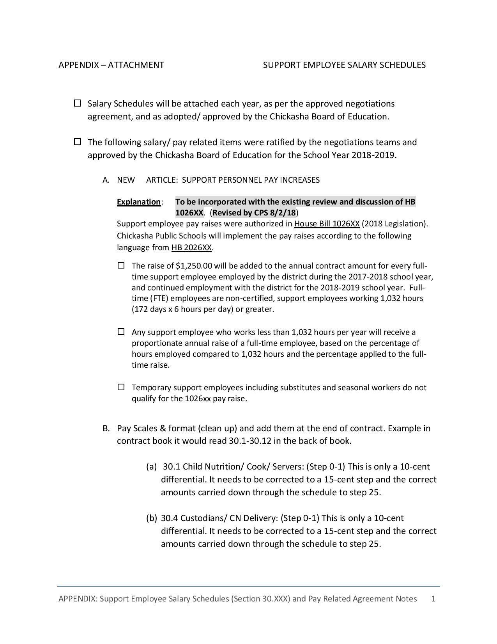

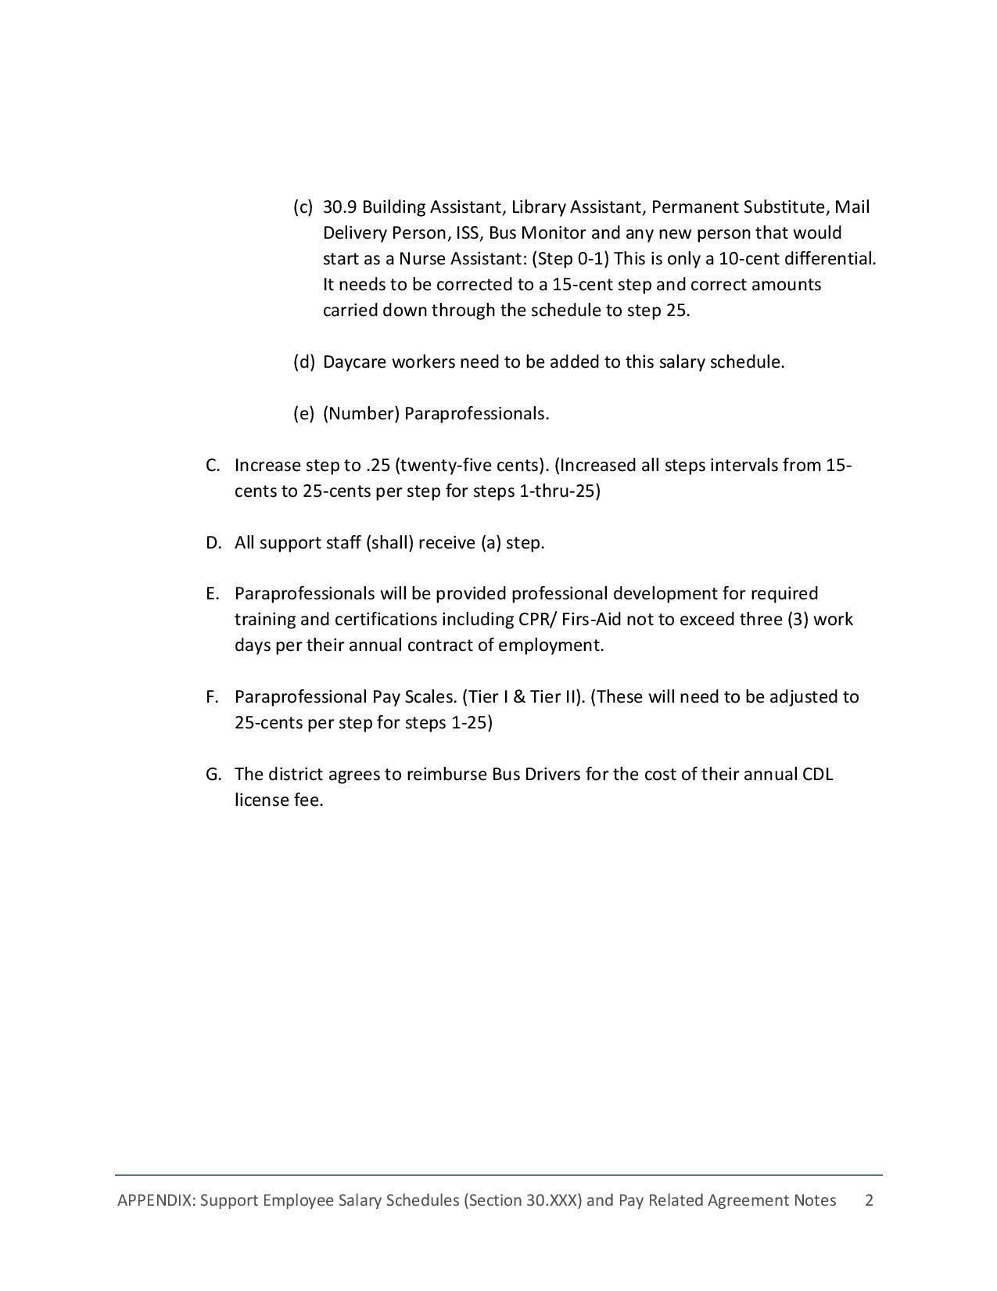

CASE PROCEDURAL AGREEMENT

**PROCEDURAL AGREEMENT**

**Between**

**Chickasha Board of Education And**

**Chickasha Association of Support Employees**

PURPOSE

The Board of Education of the Chickasha Public Schools and the Chickasha Association of Support Employees recognize the need for an orderly process of communication for administering employer/employee relations which conform with Oklahoma Statutes 70O.S.§509.1 through 509.10.

I RECOGNITION

1.1 This Agreement is made and entered into by and between the Chickasha Association of Support Employees (CASE) , hereinafter termed the "Association" and Chickasha Independent School District of Grady County, Oklahoma, hereinafter termed the "District". The governing body of the District is the Board of Education, hereinafter termed the"Board”.

1.2 The Board hereby recognizes the Association as the exclusive negotiation representative for the bargaining unit consisting of all employees who are not required by the position for which they are employed to be a principal, licensed or certified as teachers, superintendent or other certified or non-certified administrator of Chickasha Public Schools. Employees of the district with access to confidential, labor relations information of the school district and managerial employees whose responsibilities include making employment recommendations to the superintendent and for which the position does not require a certificate, shall be excluded from this or other bargaining units. Also excluded is any employee position agreed to be excluded from the bargaining unit by the association and the district. Any person who desires not to be represented by the Association may so state in writing to the Board.

1.3 The following positions shall be excluded from the bargaining unit:

* Administrative Assistant to the Superintendent
* Administrative Assistant to the Athletic Director
* Payroll Clerk
* Personnel Clerk
* Treasurer
* Encumbrance Clerk

1.4 The Board recognizes the right of all support personnel to join and participate in and support C.A.S.E. as well as to refrain from such activities. No support personnel shall be discriminated against by the Board or any administrative officer of the district, nor by C.A.S.E., or its representatives because of his/her membership, participation, support or non-membership, non-participation or non-support of C.A.S.E.

1.5 This recognition will remain in effect until verified election results show that C.A.S.E., no longer represents a majority of the support personnel of Chickasha Public Schools.

II SCOPE OF BARGAINING

2.1 The Board and C.A.S.E., agree to bargaining in good faith on wages, hours, fringe benefits and other terms and conditions of employment. There will be no bargaining on managerial rights. (Managerial rights are defined as those rights and responsibilities assigned to the Board by the School Laws of Oklahoma).

III NEGOTIATIONS PROCEDURES

3.1 Negotiation Teams

*3.1.1* The Board and C.A.S.E. shall each designate not more than six (6) representatives to serve as its negotiation team. Alternates may be designated; however, alternates will attend the meetings, only when serving in the place of a regular team member.

*3.1.2* All negotiations will take place between the designated representatives of the Board and C.A.S.E., in regular negotiation sessions.

*3.1.3* All negotiations will be conducted in closed sessions.

3.2Opening Negotiations

*3.2.1* A written request for a negotiation session between the Board and C.A.S.E., may be made by either party. This request for a negotiation session is to be made on or before May 31 of each year a negotiation session is to be held.

*3.2.2* The first meeting of a negotiation session will be held within sixty (60) calendar days of the date of written request and/or after May 31. The date, time, and place of this meeting will be mutually agreed on by the spokesperson of the respective teams.

*3.2.3* The Association shall submit all of its negotiation proposals at the first session. The Board shall submit all of its negotiation proposals at the first session.

*3.2.4* Subsequent negotiation meetings shall be held at times and places mutually agreed at the first meeting of the session

*3.2.5* All Board Proposals and All C.A.S.E., proposals will be presented at the first negotiation meeting, EXCEPT: details on salary. Proposals may be provided after the Educational Appropriations have been made by the State Legislature. Subsequent proposals may only be submitted upon mutual agreement of the parties.

*3.2.6* During meetings each party is free to caucus at any time.

3.3 Negotiations Sessions

*3.3.1* Only members of the respective negotiation teams may be present during negotiation sessions. Other parties may be permitted to be present only by mutual agreement of the parties. The chief negotiator of each team will be the spokesperson for his/her team, unless he/she designated another member to be spokesperson for that meeting. By mutual agreement of the table any team member may speak to an issue on the table.

*3.3.2* No recordings or official transcripts shall be made without mutual agreement of the parties.

*3.3.3* Negotiations will only be conducted between the representatives of the parties and only in regular negotiation sessions at the times, dates, and places mutually agreed upon by the parties. The time, date, place and agenda of subsequent sessions will be set by mutual agreement of the parties prior to the close of each negotiation session.

*3.3.4* Negotiation sessions shall be scheduled at times which will not interfere with the employee work day and the educational programs of the district.

3.4 Tentative Agreement

*3.4.1* Both parties agree that it is their mutual responsibility to empower their respective representatives with the necessary authority to make proposals, to consider proposals and counter proposals in the course of negotiations, and to reach tentative agreements subject to ratification by the Board and the Association.

*3.4.2* When tentative agreement is reached on any item, it shall be reduced to writing, and signed and dated by the spokesperson of each team. When tentative agreement is reached on all proposals, the total package shall be submitted by C.A.S.E., to the support personnel for ratification. C.A.S.E. will notify the superintendent of the results of the ratification vote not later than ten (10) working days after the total agreement has been reached by the bargaining teams. After ratification by C.A.S.E., the superintendent will present the agreement to the Board at the next regularly scheduled and or special meeting agenda. Upon ratification by the board, the written agreement shall be signed by the President of the Board and the President of C.A.S.E. The terms of the agreement will then be in full force and effect through the term of the agreement.

IV IMPASSE

4.1 In the event the bargaining team cannot reach agreement on all items being negotiated, either party may declare that impasse exists. Within two (2) working days after Declaration of impasse each party will provide to the other party, in writing, their last proposal on each of the items at impasse. The parties shall request mediation services of Federal Mediation and Conciliation service within two (2) working days of the exchange of final proposals. If the mediator is unable to bring about agreement between the parties, the issues still in dispute will be submitted to fact finding. Within five (5) working days after mediation is completed, representatives of the Board and C.A.S.E., will implement the provisions of Oklahoma Statute 70- 509.7

**The Board will be responsible for the fees and cost of its member on the Fact-finding committee. C.A.S.E., will be responsible for the cost and fees of its member on the Fact-finding committee.**

The Board and C.A.S.E., will share equally the cost and fees of the third member of the Fact-finding committee. By mutual agreement of the parties, the date for declaring impasse may be extended beyond the first day of school.

4.2 A fact finding committee consisting of three (3) members shall be formed. One (1) member shall be selected by the Association, and one (1) member shall be selected by the Board, within five (5) days. The third member shall be selected by the first two (2) members as follows: The parties shall notify the State Superintendent of Public Instruction that a fact finder is needed and request a list of potential fact finders from the State Superintendent. If no name on the list is agreeable to both parties, a coin toss shall occur with the party winning the toss having the right to strike a name from the list. The parties will then continue alternately striking names from the list until only one name remains. The person whose name remains on the list will serve as the chairperson of the fact-finding committee.

*4.2.1* The committee shall meet with the Board's and the Association's negotiation representatives for the purpose of fact finding. Within five (5) days after the selection of a chairperson, the representatives of the parties shall meet to exchange written language on each item at impasse. The exchanged documents shall be furnished to the chairperson and other members of the committee. Each item being submitted to fact finding shall show the last position taken by each negotiating team.

*4.2.2* The cost for the services of the fact-finding committee, including per diem expenses, if any, and actual and necessary travel expenses shall be shared in the following manner: The Board shall assume the expenses of the representative selected by the Board, the Association shall assume the expenses of the representative selected by the Association, and the expenses of the third member shall be shared equally by the Board and the Association.

*4.2.3* The fact-finding committee shall have authority to establish procedural rules, conduct investigations, and hold hearings during which each party shall be given an opportunity to present its case with supporting evidence.

*4.2.4* All hearings by the fact-finding committee shall be conducted in closed session.

*4.2.5* The chairperson shall convene the committee for fact finding. The committee shall meet with the representatives of both parties and, within twenty (20) days after the fact-finding meeting shall present its written recommendation to the Board and the Association. The report shall set forth findings of fact and recommendations on the issues submitted.

4.3 If either party decides it must reject one or more of the committee1s recommendations, said party must, within seven (7) days after the committee has presented its recommendations, request a meeting of the representatives who have been negotiating for the Board and the Association. The parties shall meet within seven (7) days of the request, unless both parties deem it unnecessary. At such meeting, the parties shall exchange written statements expressing each party's rationale for rejecting each recommendation found unacceptable and shall attempt to clarify any remaining differences. The representatives shall then resume a good faith effort to resolve the remaining differences; provided, after fourteen (14) days after the exchange of written statements, as provided for by this section, either party may discontinue such effort.

4.4 The Board shall file a copy of the fact-finding report with the office of the State Superintendent of Public Instruction. If the effort to resolve differences is successful, the parties shall draft a written agreement and present the agreement to both parties for ratification, and upon ratification such agreement shall also be forwarded to the State Superintendent. If the effort to resolve differences is unsuccessful, the Board shall forward to the State Superintendent in writing its final disposition of the negotiation's impasse process within thirty (30) days of the effective date of implementation.

V. NO STRIKE CLAUSE

5.1 The procedure provided for herein for resolving impasse shall be the exclusive recourse of the Association. It shall be illegal and a violation of this Agreement for the Association or the members of the bargaining unit to strike or threaten to strike as a means of resolving differences with the Board. It shall also be a violation of this Agreement for the Association or the members of the bargaining unit to strike for any reason during the term of a contract negotiated in accordance with the provisions of this Agreement.

VI SAVINGS CLAUSE

6.1 In the event that any provision of this agreement is declared invalid by statute or by a court of competent jurisdiction, nor or hereinafter, then such provisions shall no longer be operative but all other provisions of this agreement shall continue in effect. Upon request by the Board or C.A.S.E., the teams representing the Board and C.A.S.E., shall within twenty (20) working days commence negotiations for a legally permissible replacement for the provisions affected.

6.2.1 If a change in statute or decision of a court of last resort results in a change in benefits to the employees , the change will be incorporated.

VII DURATION OF AGREEMENT

7.1 This Agreement shall continue in effect for successive fiscal year periods unless notice is given, in writing, between January 1 and January 31 of any year, by either party, which the party desires to modify, amend or terminate this Agreement. Once such notice is given, negotiations related to changes in this Agreement shall commence on a mutually agreeable date within thirty (30) days of such notice.

7.2 This agreement shall take effect upon ratification and signing by the president of the respective parties and will be in full force and effect through 12:00 midnight, June 30, of the following year. Either party may commence negotiations for the terms of a successor agreement by written notification to the other party if no notification is tendered prior to the expiration date set forth above, then all terms and conditions contained herein will be renewed automatically without modification, unless either party shall request an amendment.

**ADOPTED _________________/ /__________________________**

_____________________________ _______________________________

President of the Board President of the Association

## PERFORMANCE APPRAISAL FOR SUPPORT PERSONNEL

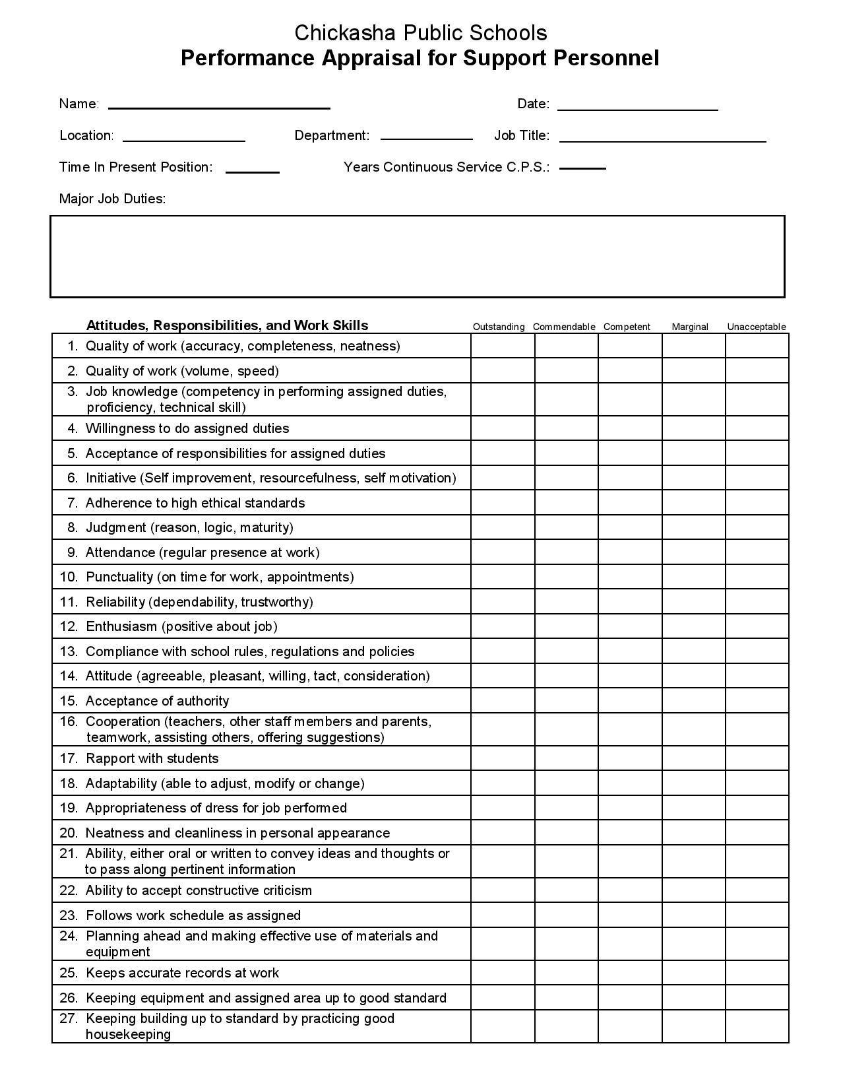

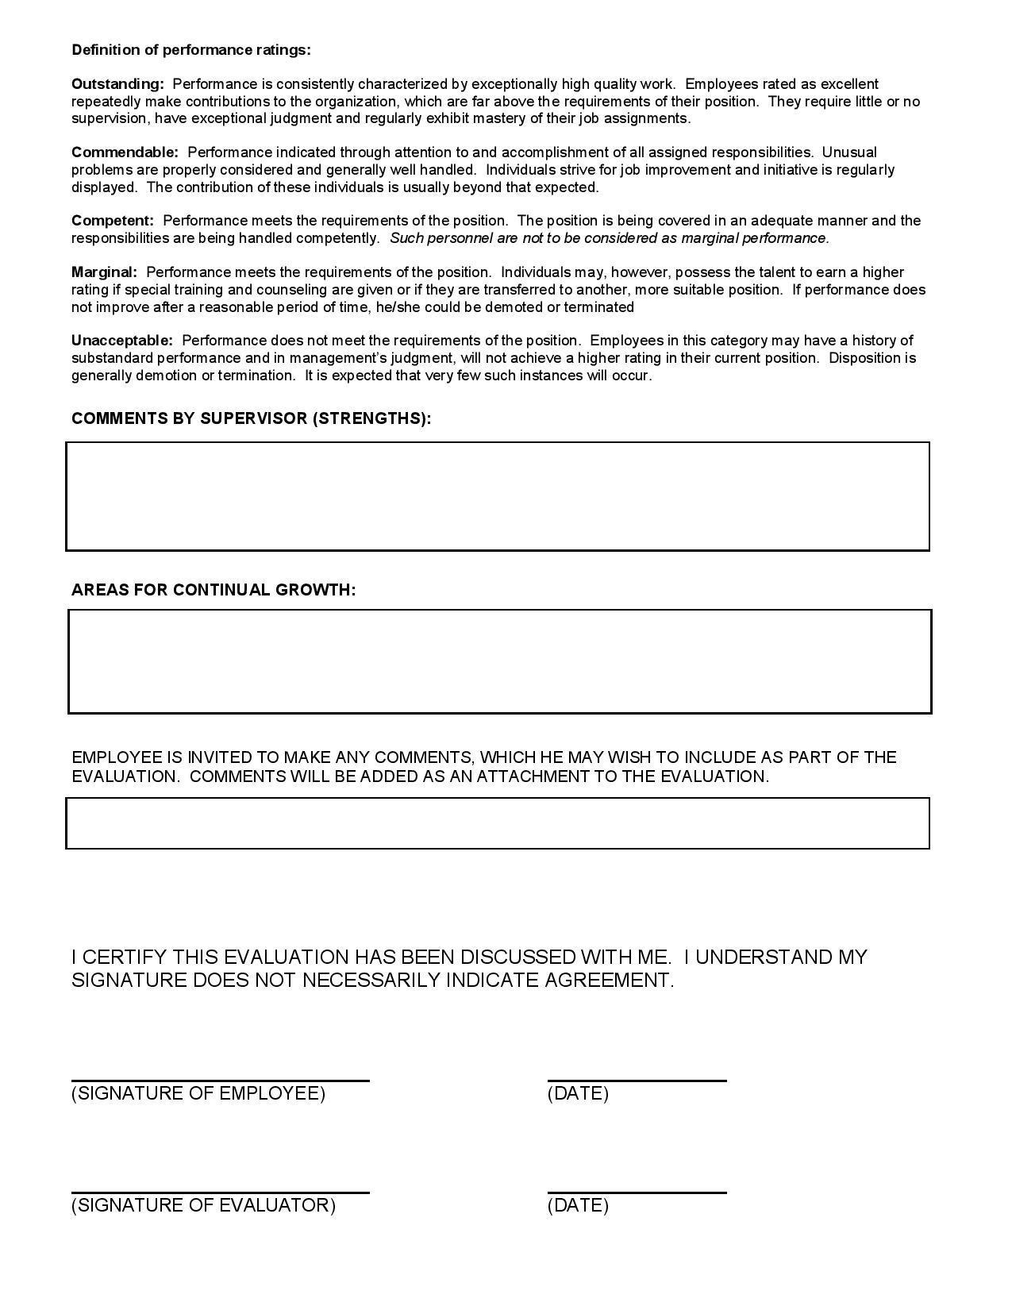

## EDUCATIONAL SUPPORT PROFESSIONAL OF THE QUARTER (NOMINATIONFORM)

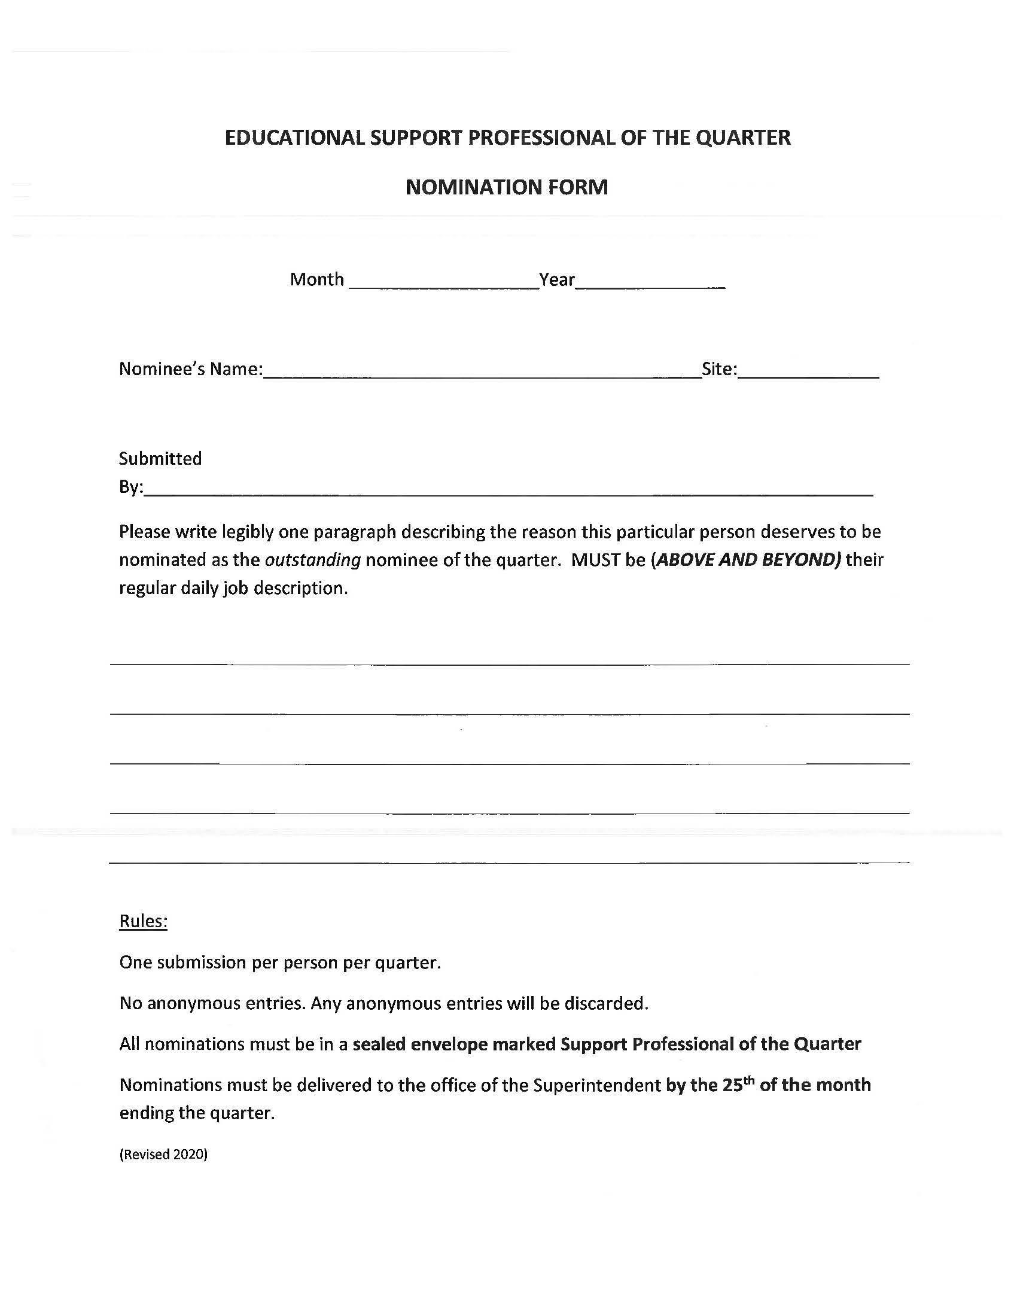

## SUPPORT PERSONNEL VOLUNTARY TRANSFER REQUEST FORM

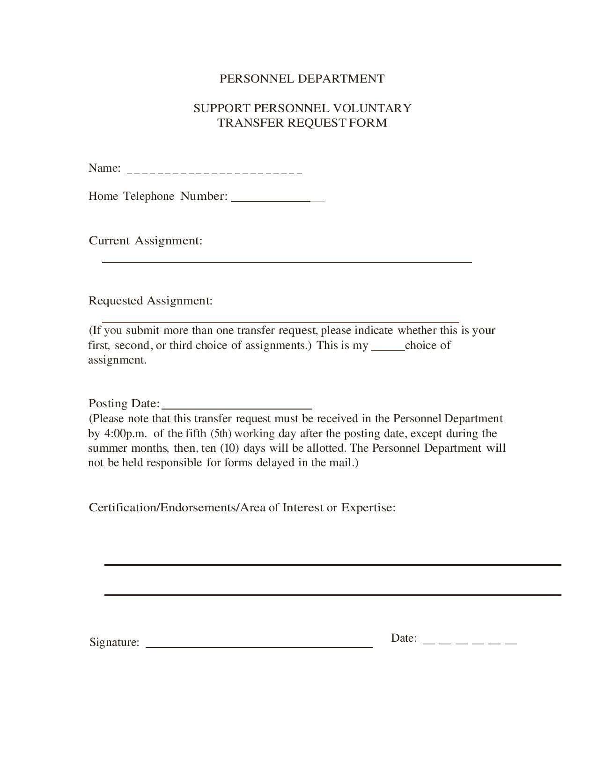

## CHICKASH PUBLIC SCHOOLS LEAVE REQUEST FORM

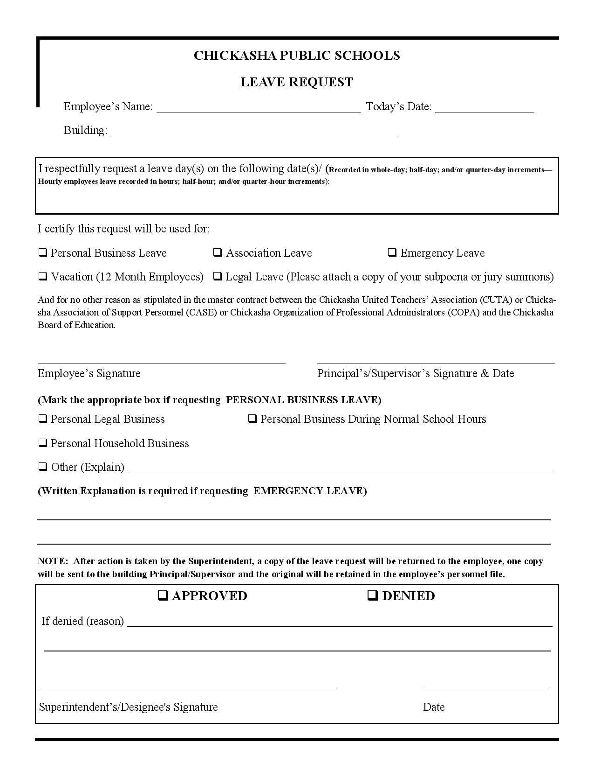

## CHICKASHA PUBLIC SCHOOL EMPLOYEE CHANGE FORM

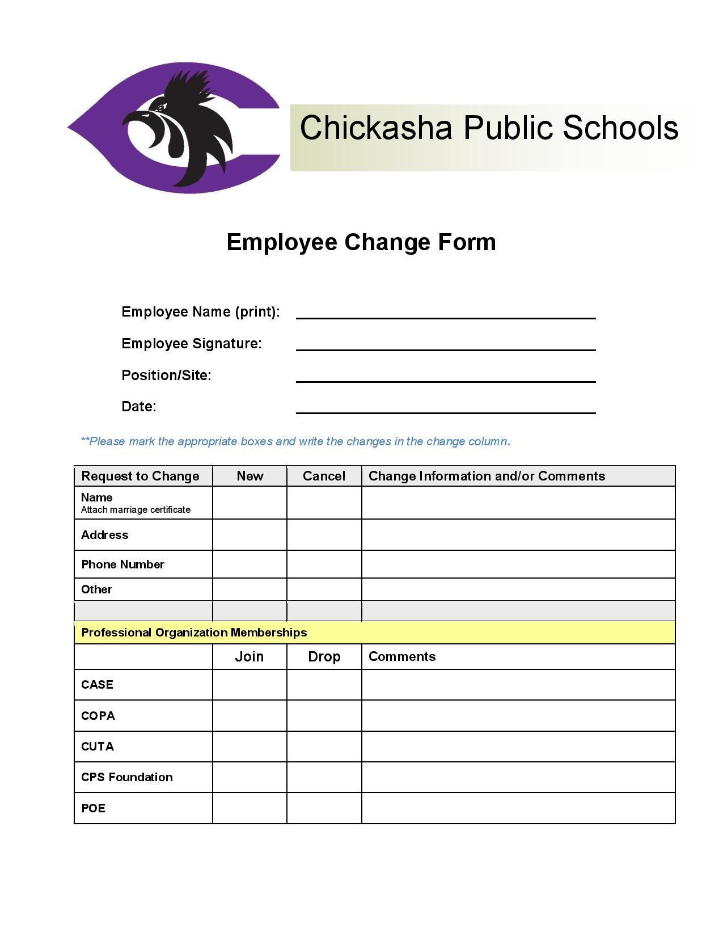

## STATE INSURANCE CHANGE OF ADDRESS FORM

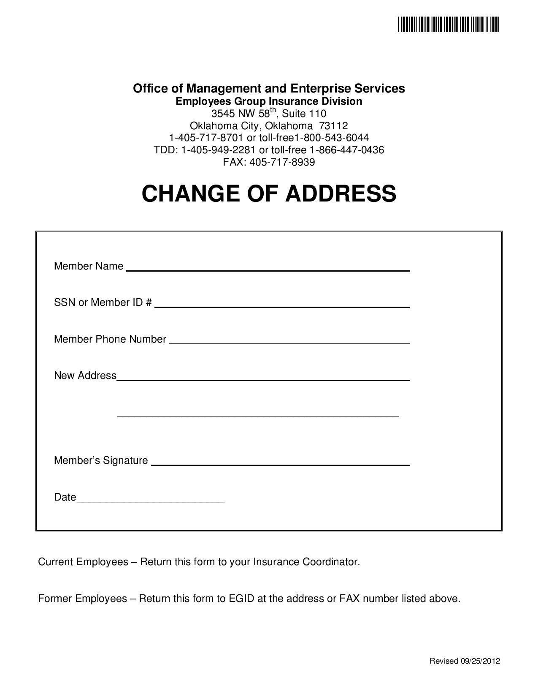

## EMPLOYEE RESIGNATION FORM

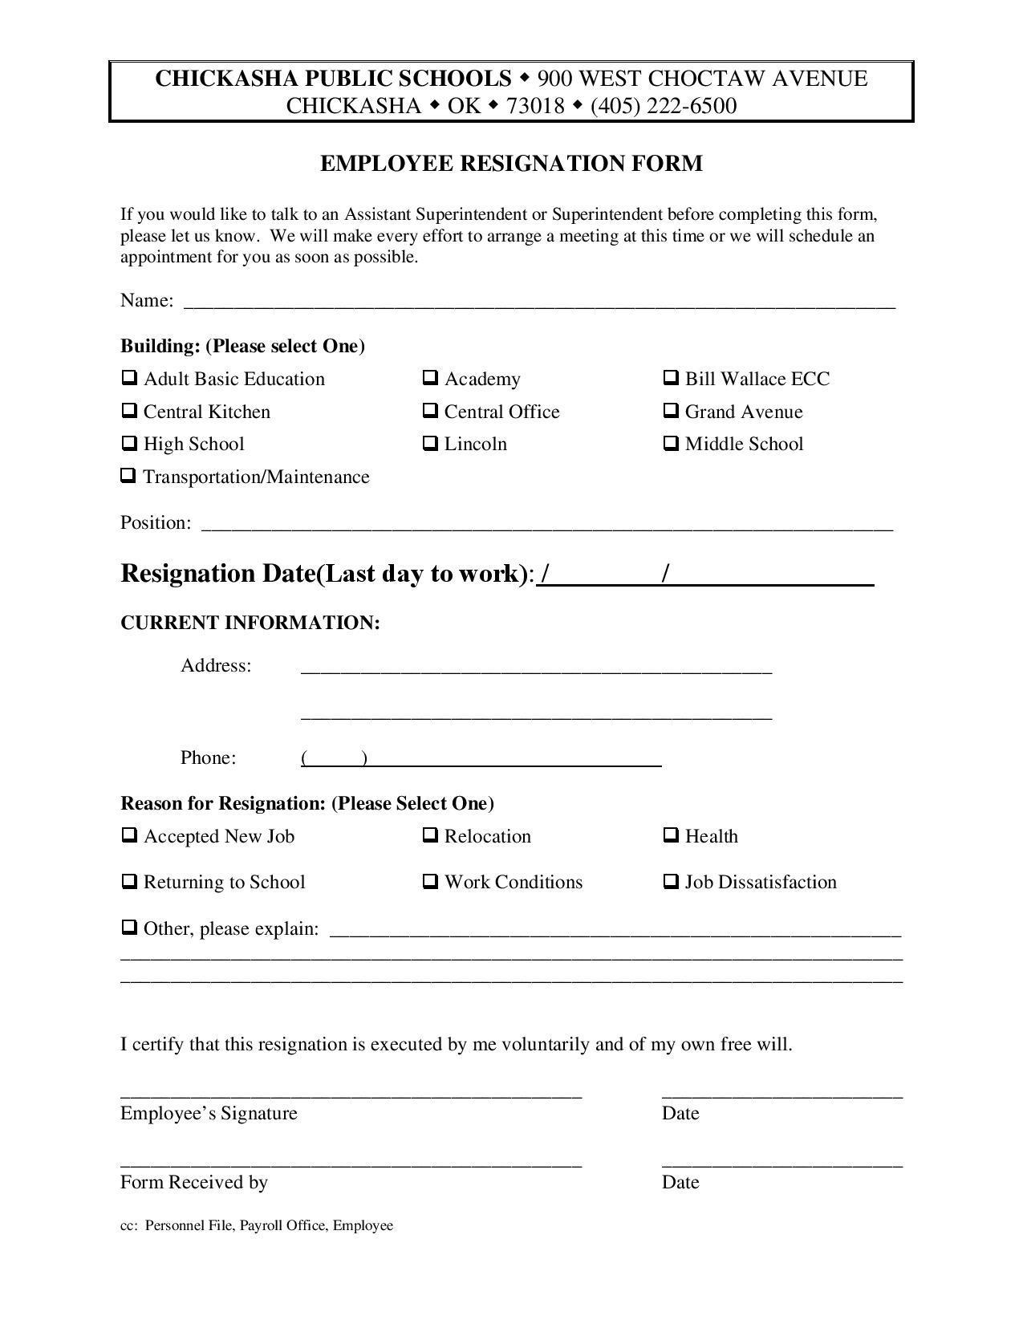

## EMPLOYEE EXIT INFORMATION FORM

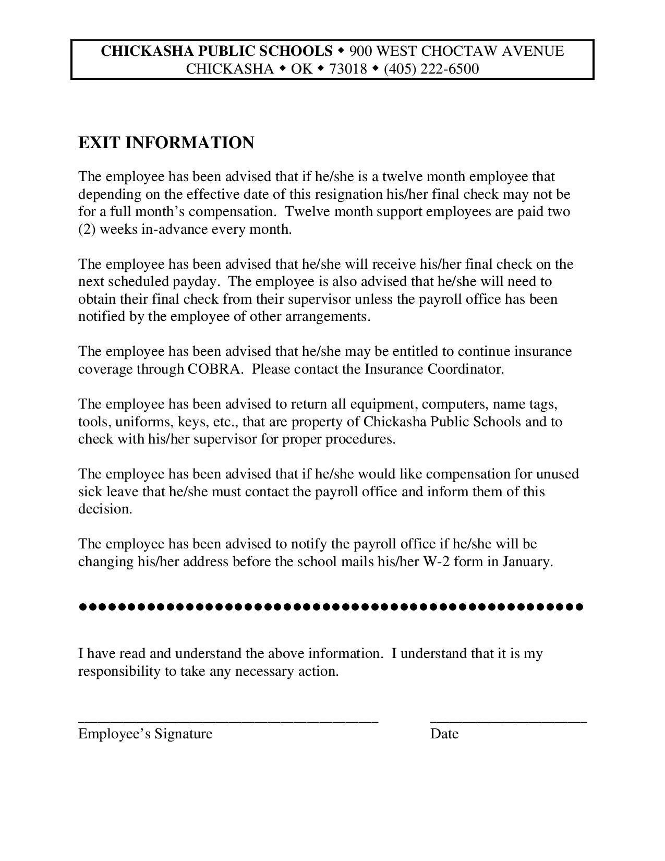

COVIDLEAVE

ChickashaPublicSchools August2022

COVID-19 Staff Leave Protocols

**COVID-19 Leave:**

* CPS is providing five (5) days of leave for any staff member that tests positive for COVID-19 during the 2022-2023 school year.
* Can be used for taking care of immediate family members that have tested positive and are quarantined, under medical orders from a doctor, for COVID-19.
* This leave would be used first in the event of a medically ordered quarantine due to a positive COVID-19 diagnosis.
* This can be spread out over multiple instances but once a staff member uses all five (5) days this leave will not be replenished. This leave does not roll over nor accumulate.
* To use this leave, provide the Personnel Office with medical documentation to quarantine and enter the reason for absence as COVID-19.

**Once the COVID-19 leave has been used a staff member will be able to:**

* Use their leave provided by CPS per the negotiated agreement.
* Use any comp days that might have been accumulated.
* If or in the event this leave is depleted, then a staff member may request for sick leave days to be donated to them through the leave bank. (See the negotiated agreement for guidelines.)

**Additional Notes**

* In the event a teacher is quarantined due to COVID-19 they may be able to teach remotely to their students. If this occurs, no leave will be entered that counts against a staff member on days that remote instruction is used for instruction. These days will have to be communicated with the site principal and Executive Director of Personnel. For a full day to be considered requires remotely teaching the regular day schedule.
* For support staff members – please contact your supervisor about online trainings, working remotely from home, or developing a plan to make up hours in the event you are quarantined. Note: Time sheets or proper documentation must be submitted by a given deadline to not have a disruption in payroll.
* In the event that schools are closed due to COVID-19, CPS will move over to remote instruction for all students enrolled in the traditional pathway. No leave will be counted against a teacher as long as instruction occurs following the regular school day schedule. Principals, teachers, and staff members will be expected to report to school sites unless instructed otherwise.
* In the event the district completely shuts down again, due to the pandemic, then the District administration will make announcements on how to proceed.

## EXTRA DUTY PAY TABLE

|  |  |  |  |
| --- | --- | --- | --- |
| **DUTY/SCHOOL/LEVEL** | | | **AMOUNT** |
| **Academic, Hourly** | | | |
| 62.1 | | Hourly Rate | $25.00 |
| **Academic, High School** | | | |
| 62.2 | | Head Coach | $2,400.00 |
| 62.3. | | Assistant Coach | $1,000.00 |
| **Academic, Middle School** | | | |
| 62.4. | | Head Coach | $1,000.00 |
| **AG** | | |  |
| 62.5. | | Sponsor | $3,000.00 |
| **Activity Manager (District 12mos)** | | | |
| 62.6 | | Manager | $4,500 |
| **Band, High School** | | |  |
| 62.7 | | Director | $12,250.00 Combined |
| ~~62.8~~ | | ~~Pep & Musical~~ | ~~$2,400.00~~ |
| ~~62.9.~~ | | ~~Assistant~~ | ~~$1,500.00~~ |
| **Band, Middle School** | | | |
| 62.10. | | Director | $6,000.00 |
| ~~62.11~~ | | ~~Assistant~~ | ~~$800.00~~ |
| ~~62.12.~~ | | ~~Pep & Musical~~ | ~~$500.00~~ |
| ~~62.13.~~ | | ~~Auxiliary/Rifles~~ | ~~$200.00~~ |
| **Band, District Wide, All Levels** | | | |
| ~~62.14.~~ | | ~~Solo/Ensemble~~ | ~~$450.00~~ |
| ~~62.15.~~ | | ~~Assistant Auxiliary/Rifles~~ | ~~$450.00~~ |
| ~~62.16.~~ | | ~~Summer~~ | ~~$2,400.00~~ |
| ~~62.17.~~ | | ~~Stage Band~~ | ~~$1,500.00~~ |
| ~~62.18.~~ | | ~~Stage Band~~ | ~~$400.00~~ |
| 62.19 | | Band Percussion | $3,250.00 |
| 62.20 | | Color Guard | $3,000.00 |
| **Building Test Coordinator** | | | |
| 62.21 | | Building Test Coordinator | $1,000.00 |
| **Class Sponsor, High School** | | | |
| 62.22. | | Seniors | $500.00 |
| 62.23. | | Juniors | $1000.00 |
| 62.24. | | Sophomore | $500.00 |
| 62.25. | | Freshman | $500.00 |
| **Department Head** | | | |
| 62.26. | | High School | $750.00 |
| 62.27. | | Middle School | $750.00 |
| 62.28. | | Elementary School | $750.00 |
| **District Faculty Liaison** | | | |
| 62.29. | | C.U.T.A. President (Liaison) to provide consultation and representation for the District. He/she will provide a written report monthly to the Superintendent for services to the District. The written monthly report is expected to provide a summary of the current “state of the Chickasha United Teachers Association” (membership activities, concerns, outreach, to the community, legislative goals, etc.) | $750.00 |
| **District Teacher of the Year** | | | |
| 62.30. | | District Teacher of the Year after:  1. Completion of the State application in its entirety  2. Expectation of remaining a classroom teacher in the following school year. | $1,500.00 |
| **Drama** | | | |
| 62.31 | | High School | $2,000.00 |
| **ESports (District)** | | | |
| 62.32 | Coach | | $1,500.00 |
| **Gifted & Talented, Middle School** | | | |
| 62.33. | | Coordinator- Grades 6th-8th | $1,500.00 |
| **High School Spirit Club** | | | |
| 62.34 | | High School Spirit Club | $3,000.00 |
| **Indian Education District Wide** | | | |
| 62.35 | Coordinator | | $2,000 |
| **McKinney-Vento Site Liaison** | | | |
| 62.36 | McKinney-Vento Site Liaison | | $1,000.00 |
| **Mentor Teacher** | | | |
| 62.37 | Mentor | | $500 |
| **National Honor Society, High School** | | | |
| 62.38. | | Sponsor | $500.00 |
| **National Honor Society, Middle School** | | | |
| 62.39 | | Sponsor | $450.00 |
| **Media, High School** | | | |
| 62.40 | | Director | $750.00 |
| **Newspaper, High School** | | | |
| 62.41. | | Director | $600.00 |
| **Odyssey of the Mind, District Wide** | | | |
| 62.42. | | Coach | $250.00 |
| **Psychological Services, District Wide** | | | |
| 62.43. | | *Individual serving as both Psychometrist/Psychologist | $8,000.00 |
| 62.44. | | Psychologist | $5,000.00 |
| 62.45. | | Psychometrist | $4,000.00 |
| **Robotics, High School** | | | |
| 62.46. | | Head Coach | $4,000.00 |
| 62.47 | | Assistant Coach | $1,000.00 |
| **Robotics, Elementary Coach** | | | |
| 62.48. | | Head Coach | $1,500.00 |
| 62.49 | | Assistant Coach | $750.00 |
| **Science Fair, District Wide** | | | |
| 62.50. | | Coordinator | $250.00 |
| **Special Education** | | | |
| 62.51. | | Speech Pathologist | $8,000.00 |
| 62.52. | | Speech Therapist Assistant | $2,500.00 |
| 62.53 | | Special Education Over Caseload Stipend (Based on Oct. 1 child count) | $1000 per year  $500 per semester  $250 per nine weeks |
| 62.54 | | Special Education IEP Writer | $2,500.00 |
| 62.55 | | Special Education Bootcamp | $1,500.00 |
| **Student Government, High School** | | | |
| 62.56. | | Sponsor | $2,000.00 |
| **Student Government, Middle School** | | | |
| 62.57. | | Sponsor | $300.00 |
| **Technology Mentor** | | | |
| 62.58 | | Technology Mentor (Each Site) | $1,000 |
| **Trainers** | | | |
| 62.59 | | Paraprofessional Trainer/CPI Trainer | $20/hr |
| **Vocal Music, High School** | | | |
| 62.60 | | Director | $3,500.00 |
| **Vocal Music, Middle School** | | | |
| 62.61. | | Director | $1,000.00 |
| **Vocal Music, Elementary** | | | |
| 62.62. | | Director- Select Choir | $500.00 |
| **Vocal Music- District Wide, All Levels** | | | |
| 62.63. | | Coordinator | $500.00 |
| **Website (Each Site)** | | | |
| 62.64 | | Site webmaster | $1,000.00 |
| **Yearbook, High School** | | | |
| 62.65 | | Sponsor | $1,500.00 |
| **Yearbook, Middle School** | | | |
| 62.66. | | Sponsor | $750.00 |
| **Yearbook,Elementary** | | | |
| 62.67. | | Sponsor | $500.00 |
| **ATHLETICS** | | | |
| **Assistant Student Activities Director** | | | |
| 62.68 | | Assistant Student Activities Director | $6500.00 |
| **Archery** | | | |
| 62.69 | | High School Head Coach | $1,500.00 |
| 62.70 | | Middle School Head Coach | $1,500.00 |
| 62.71 | | Elementary Head Coach | $1,500.00 |
| 62.72 | | Assistant Coach | $1,000.00 |
| **Baseball, High School** | | | |
| 62.73 | | Head Coach- Varsity | $6,000.00 |
| 62.74. | | Assistant- Varsity | $3,000.00 |
| 62.75. | | Assistant- Varsity | $3,000.00 |
| **Baseball, Middle School** | | | |
| 62.76 | | Head Coach | $1,750.00 |
| 62.77. | | Assistant | $1,000.00 |
| 62.78 | | Assistant | $1,000.00 |
| **Basketball, High School** | | | |
| 62.79. | | Head Coach- Varsity Boys | $7,500.00 |
| 62.80 | | Assistant- Varsity Boys | $3,000.00 |
| 62.81 | | Assistant- Varsity Boys | $3,000.00 |
| 62.82 | | Head Coach- Varsity Girls | $7,500.00 |
| 62.83 | | Assistant- Varsity Girls | $3,000.00 |
| 62.84 | | Assistant- Varsity Girls | $3,000.00 |
| 62.85 | | Head Coach- 9th Grade Boys | $2,400.00 |
| 62.86 | | Head Coach- 9th Grade Girls | $2,400.00 |
| 62.87 | | Video | $600.00 |
| **Basketball, Middle School** | | |  |
| 62.88. | | Head Coach- 7th Grade Boys | $1,500.00 |
| 62.89. | | Head Coach- 7th Grade Girls | $1,500.00 |
| 62.90. | | Head Coach- 8th Grade Boys | $1,500.00 |
| 62.91. | | Head Coach- 8th Grade Girls | $1,500.00 |
| 62.92. | | Intramural | $600.00 |
| **Basketball, Elementary** | | |  |
| 62.93. | | Head Coach | $500.00 |
| **Cheerleading, High School** | | | |
| 62.94. | | Head Coach | $4,800 |
| 62.95. | | Assistant Coach | $1,750 |
| 62.96 | | Assistant Coach | $1,750 |
| **Cheerleading, Middle School** | | |  |
| 62.97. | | Head Coach | $2,000.00 |
| 62.98. | | Assistant Coach | $750.00 |
| 62.99. | | Assistant Coach | $750.00 |
| **Clay Shooting** | | | |
| 62.100 | | Clay Shooting (District) | $1,500.00 |
| **Cross Country, High School** | | |  |
| 62.101 | | Head Coach- Boys | $3,200.00 |
| 62.102. | | Assistant Coach- Boys | $1,750.00 |
| 62.103. | | Head Coach- Girls | $3,200.00 |
| 62.104. | | Assistant Coach- Girls | $1,750.00 |
| **Cross Country, Middle School** | | | |
| 62.105. | | Head Coach- Boys & Girls | $2,500.00 |
| **Football, High School** | | |  |
| 62.106. | | Head Coach- Varsity | $10,000.00 |
| 62.107. | | Defensive Coordinator | $5,000.00 |
| 62.99. | | Offensive Coordinator | $5,000.00 |
| 62.108. | | Assistant | $4,000.00 |
| 62.109 | | Assistant | $4,000.00 |
| 62.110 | | Assistant | $4,000.00 |
| 62.111 | | Assistant | $4,000.00 |
| 62.112 | | Head Coach- 9th Grade | $2,400.00 |
| 62.113 | | Spring Director | $800.00 |
| 62.114 | | Video | $800.00 |
| **Football, Middle School** | | | |
| 62.115 | | Head Coach- 7th Grade | $2,400.00 |
| 62.116 | | Assistant | $1,500.00 |
| 62.117 | | Assistant | $1,500.00 |
| 62.118 | | Assistant | $1,500.00 |
| 62.119. | | Head Coach- 8th Grade | $2,400.00 |
| 62.120 | | Assistant | $1,500.00 |
| 62.121 | | Assistant | $1,500.00 |
| 62.122 | | Assistant | $1,500.00 |
| **Golf- High School** | | |  |
| 62.123 | | Head Coach- Varsity Boys | $3,200.00 |
| 62.124 | | Head Coach- Varsity Girls | $3,200.00 |
| 62.125 | | Assistant Coach - Varsity | $2,250.00 |
| **Golf- Middle School** | | |  |
| 62.126 | | Head Coach- Boys | $1,250.00 |
| 62.127 | | Head Coach- Girls | $1,250.00 |
| **Pom, High School** | | |  |
| 62.128 | | Head Coach | $5,800.00 |
| 62.129 | | Assistant | $2,500.00 |
| 62.130 | | Assistant | $2,500.00 |
| 62.131 | | Assistant | $2,500.00 |
| **Pom, Middle School** | | | |
| 62.132 | | Head Coach | $2,500.00 |
| 62.133 | | Assistant | $1,250.00 |
| 62.134 | | Assistant | $1,250.00 |
| **Powerlifting, High School** | | |  |
| 62.135 | | Head Coach | $3,200.00 |
| **Powerlifting, Middle School** | | |  |
| 62.136 | | Head Coach | $1,500.00 |
| **Soccer, High School** | | |  |
| 62.137 | | Head Coach- Varsity Boys | $6,000.00 |
| 62.138 | | Assistant- Varsity Boys | $2,500.00 |
| 62.139 | | Assistant- Varsity Boys | $2,500.00 |
| 62.140 | | Head Coach- Varsity Girls | $6,000.00 |
| 62.141 | | Assistant- Varsity Girls | $2,500.00 |
| 62.142 | | Assistant- Varsity Girls | $2,500.00 |
| **Soccer, Middle School** | | |  |
| 62.143 | | Head Coach- Boys | $2,250.00 |
| 62.144 | | Assistant- Boys | $1,500.00 |
| 62.145 | | Head Coach- Girls | $2,250.00 |
| 62.146 | | Assistant- Girls | $1,500.00 |
| **Softball, High School** | | |  |
| 62.147. | | Head Coach- Varsity | $5,700.00 |
| 62.148. | | Assistant- Varsity | $2,800.00 |
| 62.149 | | Assistant- Varsity | $2,800.00 |
| **Softball, Middle School** | | |  |
| 62.150. | | Head Coach | $1,750.00 |
| 62.151. | | Assistant | $1,000.00 |
| **Special Olympics** | | |  |
| 62.152. | | Head Coach | $1,000.00 |
| 62.153. | | Assistant Coach *if more than 5 students | $500.00 |
| **Spirit Squad, Grand/District Wide** | | |  |
| 62.154. | | Head Coach | $20.00 per hour |
| 62.155 | | Assistant | $20.00 per hour |
| 62.156 | | Assistant | $20.00 per hour |
| **Strength and Conditioning High School** | | |  |
| 62.157 | | Coach | $4,000.00 |
| **Swimming- High School** | | |  |
| 62.158. | | Head Coach-Varsity Boys | $2,200.00 |
| 62.159 | | Assistant- Varsity Boys | $750.00 |
| 62.160. | | Head Coach- Varsity Girls | $2,200.00 |
| 62.161. | | Assistant- Varsity Girls | $750.00 |
| **Swimming- Middle School** | | |  |
| 62.162 | | Head Coach- Boys & Girls | $1,000.00 |
| **Tennis- High School** | | |  |
| 62.163. | | Head Coach- Varsity Boys | $3,200.00 |
| 62.164 | | Assistant- Varsity Boys | $1,500.00 |
| 62.165. | | Head Coach- Varsity Girls | $3,200.00 |
| 62.166. | | Assistant- Varsity Girls | $1,500.00 |
| **Tennis- Middle School** | | |  |
| 62.167. | | Head Coach- Boys | $2,000.00 |
| 62.168. | | Head Coach- Girls | $2,000.00 |
| **Track- High School** | | |  |
| 62.169. | | Head Coach- Varsity Boys | $4,000.00 |
| 62.170. | | Assistant- Varsity Boys | $2,000.00 |
| 62.171. | | Head Coach- Varsity Girls | $4,000.00 |
| 62.172 | | Assistant- Varsity Girls | $2,000.00 |
| **Track- Middle School** | | |  |
| 62.173. | | Head Coach- Boys | $1,000.00 |
| 62.174. | | Assistant- Boys | $750.000 |
| 62.175. | | Head Coach- Girls | $1,000.00 |
| 62.176 | | Assistant- Girls | $750.00 |
| **Volleyball- High School** | | |  |
| 62.177. | | Head Coach- Varsity | $3,900.00 |
| 62.178. | | Assistant | $1,500.00 |
| **Volleyball- Middle School** | | |  |
| 62.179. | | Head Coach | $3,400.00 |
| 62.180. | | Assistant | $1,250.00 |
| **Weight Room, High School/District Wide** | | |  |
| 62.182. | | Program Supervision | ~~$10.00~~ per hour |
| **Wrestling, High School** | | |  |
| 62.183. | | Head Coach- Varsity | $6,000.00 |
| 62.184. | | Assistant | $2,500.00 |
| 62.185 | | Assistant | $2,500.00 |
| 62.186 | | Assistant | $2,500.00 |
| **Wrestling, Middle School** | | |  |
| 62.187. | | Head Coach | $2,250.00 |
| 62.188. | | Assistant | $1,500.00 |
| 62.189 | | Assistant | $1,500.00 |
| 62.190 | | Assistant | $1,500.00 |

*Only available to certified staff